**Automatic Transporter Mechanism (ATM)**

**University Student/Faculty available UTV concept miniature prototype**

**Briefing:** This is a modular project developed for the class ENGE 1216 provided at Virginia Polytechnic Institute of Technology. The purpose was to fulfill an engineering challenge related to one of the plethora of challenges we face in the present. For this project we’ve decided to tackle the problem of transportation on college campus. To solve this issue, an automatic vehicle concept was manifested. As this project is significantly complicated, it is necessary for all the components to fit perfectly else the project will miss a functionality criterion. Thus, the creation of an extremely detailed documentation was started. This is both to help others understand the “whats” and the “whys” of the project but also to inspire recreating some specific aspects of the project as inspiration for others.

**About this documentation:** This documentation will contain every explanation possible about the inner workings and interactions the project has with the real world. All components and modules will be addressed, manufacturing methods, programs used, etc. Everything will be sorted into several different categories listed below in the **table of contents**.

1. **Functionality**
   1. **Controls** ……………………………………………………………………….. **[3]**
   2. **Modes** ………………………………………………………………………… **[5]**
   3. **Motors** ………………………………………………………………………… **[6]**
   4. **Limitations** ……………………………………………………………………. **[7]**
2. **Construction**
   1. **Physical layout** …………………………………………………………………**[8]**
   2. **Construction methods** …………………………………………………………**[9]**
   3. **3D Model mounting and installing** …………………………………………...**[9]**
3. **CAD modeling**
   1. **Cad Models produced** ………………………………………………………..**[11]**
   2. **Programs used** ………………………………………………………………..**[11]**
   3. **Files used** ……………………………………………………………………...**[12]**
   4. **Techniques for modeling** ……………………………………………………..**[13]**
   5. **Design reasoning** ……………………………………………………………...**[14]**
4. **Circuit Design**
   1. **Automatic Lights** ……………………………………………………………..**[16]**
   2. **Turn Signals** ……………………………………………………………….....**[17]**
   3. **H-Bridge Circuit** ……………………………………………………………...**[18]**
   4. **Level Shifting** …………………………………………………………………**[20]**
   5. **UART chain** …………………………………………………………………..**[20]**
5. **Programming**
   1. **BLE Server** ……………………………………………………………………**[21]**
   2. **Automatic Reactions** …………………………………………………………**[24]**
   3. **OLED Serial Mirroring** ……………………………………………………...**[26]**
   4. **IOS Application** ………………………………………………………………**[28]**

**Table of Contents Continued.**

1. **Components**
   1. **Components for each module** ………………………………………………..**[33]**
   2. **Microcontrollers**
   3. **Master list of parts**
   4. **Reasons for including parts**
2. **Rates**
   1. **Sampling rates**
   2. **Command stack rates**
   3. **Re-connectivity rate**
3. **Warnings**
   1. **Bootup quirks**
   2. **Flashing quirks**
   3. **Motor voltage isolation**
   4. **High Side Transistor Switch**
   5. **Decoupling charge.**
4. **System**
   1. **Serial Mode**
   2. **BLE peripheral**
   3. **Versions**
5. **Demo**
   1. **What was assessed as the core criteria**
   2. **Physical prototype demo review**
6. **Future**
   1. **Improvements considered**
7. **Acknowledgements**
   1. **Team members**
   2. **Sources used**

**Note from author:** This document is a live document, so not everything will be covered right away. Until further clarification, please regard the info provided in this document as both relevant and subject to change. If there are questions about incomplete explanations about any aspect of this project, please contact me via: [nathan@fikesfarm.com](mailto:nathan@fikesfarm.com) or [nfikes@vt.edu](mailto:nfikes@vt.edu). If these contacts are insufficient, please send a pull request at my GitHub repository: <https://github.com/nfikes/AutomaticVehicle>. I hope you find anything in this document extremely useful for understanding the project.

Thank you,

Nathan Fikes

**Functionality**

**Controls History:** As this is a prototype, it is meant to mimic the controls of an actual vehicle. To achieve this, we had planned to add physical controls to the vehicle. This included using 4 DigiKey JS202011CQN Slide switches. However, after further inspection and physical trial, switches such as these were inoperable at such a small scale as well as being breadboard mounted. Other such controls included using a DigiKey PTV09A-403F-A104 100 kΩ Potentiometer for steering and two generic circuit push buttons for pedals. Our initial criteria for vehicle controls were to be Yoke steering, Pedal movement, and Bistable Latch accessory component control (Aka, lights, locks, sound, air for normal vehicles). As these features are typically unsuitable for a scale as small as this, we’ve decided to change the control scheme to make it much easier to control the prototype, however, this is not the intent of the final vehicle.

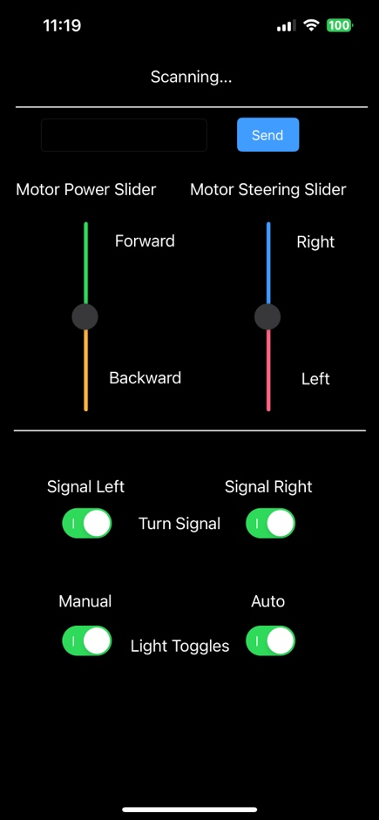**Controls:** To interact with the vehicle, we’ve developed an application in XCode using Objective-C for IOS 17.0.1. As soon as both the app and vehicle are booted, they should connect automatically. This works regardless of which host device is trying to connect, whether that be your phone or your friends (You just can’t connect simultaneously). Once the app is running a screen shown in Figure 1 should appear. Several controls and labels will appear to allow interaction with the vehicle.

**Text Field:** Send specific commands to the vehicle using the command tag list.

“P” – Motor power (Integer -100 – 100)

“S” – Steering angle (Integer -90 – 90)

“L” – Left Turn Light (Integer 1 or 0)

“R” – Right Turn Lights (Integer 1 or 0)

“M” – Manual Mode Lights (Integer 1 or 0)

“A” – Auto Mode Lights (Integer 1 or 0)

To send a command to the vehicle using the text field feature, type the tag (Capital letter) first and then immediately after, place your number. If you want the vehicle to move forward with 50% motor power, type “P50” into the text field. If you want to turn 35° to the left, type “S-35” into the text field. If you would like to turn on the left turn signal, type “L1” etc. Press [Send] to send that packet to the vehicle and it will interpret what command you have sent. (The input fields are recommended to be integers, however the vehicle should be able to automatically convert any rational numbers, so long as they are not full equations.)

Figure 1: Vehicle Controller application main screen

**Slider Controls:** There are a couple of labeled sliders. Pulling them down or up will cause several commands to be sent to the vehicle according to the slider position. This allows only movement controlling but it does it at a faster rate than spamming the text field. One feature of the sliders is that if you let go of a slider in a position, it will gradually go back to 0. To hold a slider in a spot, drag the slider to a position you want, then let go. After letting go tap on the other slider and the original slider will hold its position. This is useful for setting constant speed.

**Button Controls:** There are four toggle buttons. Each one is labeled for their specific function, and spanning the middle is a short description. These buttons essentially send the L R M A commands. Pressing a button will send that command to the car without needing to press send on the text field.

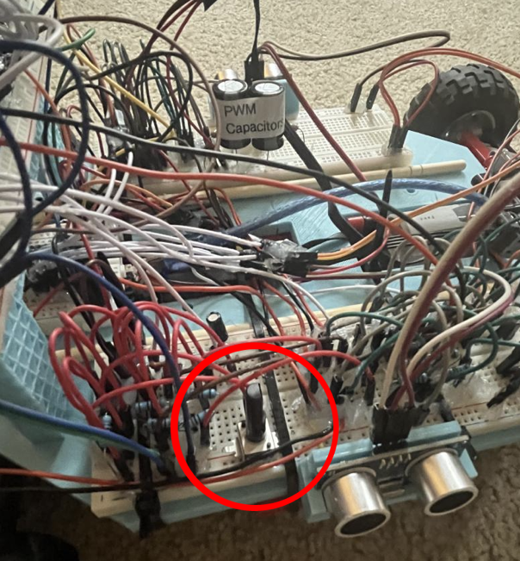**Onboard Vehicle Control:** I know I said I revoked all the onboard vehicle controls but there is still one on there that is still used. Onboard the left side of the vehicle is one of those DigiKey PTV09A-403F-A104 100 kΩ Potentiometers, and it is used to edit the speed of the turn signal blinking.

**Turning the knob to the left** increases the frequency to a max rate that is indistinguishable to our eyes.

**Turning the knob to the right** decreases the frequency to a min rate that is about 1 Hz.

# For vehicles to be road safe they must have working lights. From standard regulations “Turn signals are required to blink on and off, or "flash", at a steady rate of between 60 and 120 pulses per minute (1–2 Hz). International UN Regulations require that all turn signals flash in simultaneous phase;” (Automotive lighting). Thus, the rate can be customized a bit, however regulations require it to be a steady rate. Furthermore, each turn signal is on a simultaneous phase which will be explained later.

Figure 2: Location of Turn Signal Cycle Frequency Control

**Control override:** The vehicle has an automatic feature called Auto-Reaction. Using the 4 onboard Ultrasound as a physical ambient object sonar system, the vehicle can override user control. For instance, if the user would like to ram the front of the car into an obstacle, the vehicle will detect that wall with its front sensor and override user control stopping the user from hitting the wall. This is a safety feature that is permanently active. However, for convenience, the feature doesn’t interact with user control when there are no obstacles present. This leaves the vehicle feeling like a normal car, just with a couple safety features superimposed.

**Fun unique feature (exclusive to small prototype):** Due to the Auto-Reaction system being active, you can technically control the prototype by holding your hand in front of one or more of the sensors. This effectively allows the car to move without using the application. Though the lights are still uncontrollable on the vehicle itself, they require the lights.

**Functionality**

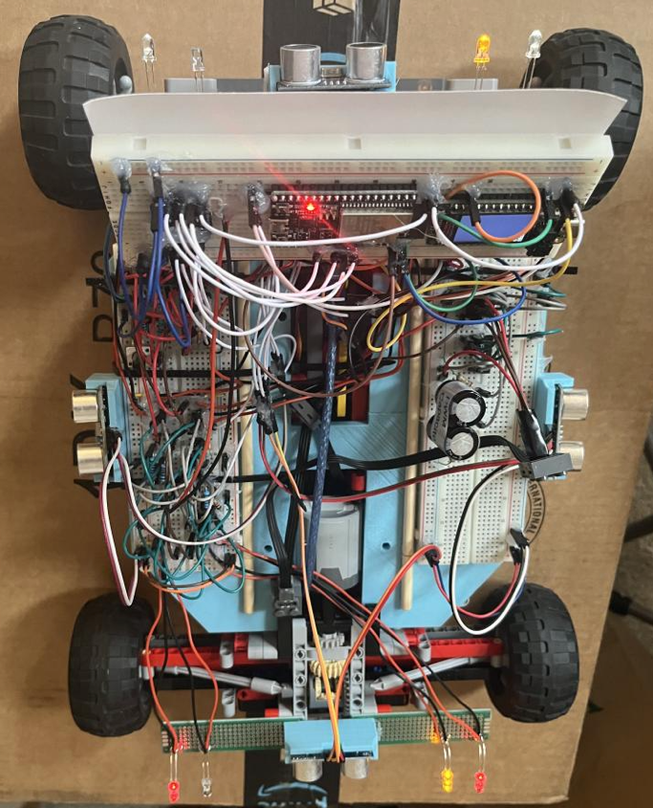**Modes:** There are multiple different light states the car can be in, and a couple of the modes may be confusing. The 4 toggle buttons on the bottom of the vehicle, as well as the text field, can modify the light mode the car is in. Keep in mind the default mode for the car when booting is Hazard Mode and Automatic Lights. Also, keep in mind all these modes refer to the lights. Figure 3 depicts a certain light mode state.

**Signal Left Mode:** This mode when toggled on will allow the yellow lights on the Left Side of the vehicle to use the ongoing timer cycle. These lights will remain blinking until the mode is turned off.

**Signal Right Mode:** This mode is exactly like the Left Mode, though this mode interacts with the right side of the car. This is also a toggle so the lights will remain on until the mode is turned off.

**Hazard Mode:** Turning on both Left and Right modes will allow the car to blink the lights on the same phase, essentially putting the vehicle into hazard lights mode. Regardless of what part of the phase one of the modes was in, turning on the other mode will always land on the same phase. This is because both modes are using the same clock cycle.

**Manual Mode:** This mode interacts with the visibility lights. When the mode is on, it allows power to all 4 lights in the system (2 Red in the back and 2 White in the front.) **Turning this mode ON allows you to use the Auto Mode.** You cannot use the Auto Mode with Manual Mode turned off. Turning the Manual mode off will cut power to the four lights mentioned before. Keep in mind this mode doesn’t interact with the turn signals. Manual Mode takes precedence over Auto Mode, meaning Manual Mode can control over Auto Mode.

Figure 3: Vehicle in Signal Right Mode, Manual Mode, and Auto Mode.

**Auto Mode:** Think of this mode as High Beams/Low Beams. When Manual Mode is active, you can use the features of the Auto Mode. (Assume Manual Mode is on for these descriptions) When Auto Mode is active, the vehicle uses an onboard photoresistor voltage divider circuit in junction with an NPN transistor to modify the *Front*headlight brightness based on ambient lighting. For nighttime the front lights should be bright when Auto is active. Vice versa, for daytime, the front lights should be dimmer. Turning off Auto Mode usually makes the lights much brighter because there is no voltage divider circuit determining brightness. Auto Mode off allows the lights to get full power. (Think of it as Auto off – High beams, Auto on – Low beams).

**Functionality**

**Motors:** There are two motors mounted onto the vehicle. There is an Arduino Stepper Motor mounted on the front, and there is a Lego PF XL Motor on the back. These two motors provide complete control over the vehicle movement dynamics.

**Arduino Stepper:** This motor is mounted to the front of the vehicle and is attached to a Rack and Pinion setup. When the vehicle receives motor steering commands, this motor will handle steering. As shown in Figure 4, the motor assembly is underneath the vehicle. The Arduino motor will rotate to provide turning functionality for the vehicle. One quirk about this setup is that the Arduino motor has a closed loop system (PID possibly), so you may hear sounds coming from the motor as it is fighting environment forces to move the rack. Generally, this is really good for locking in a rotation while turning. Quirks will be elaborated in the quirks section.

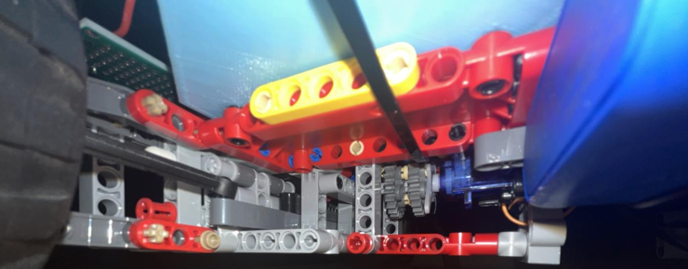

Figure 4: Mounting location of the Arduino stepper motor. The stepper motor is mounted on the Right side, and the rack and pinion assembly are on the Left side. Arduino motor rotates to provide lateral movement on the rack.

**Lego PF XL:** This motor is mounted on the back of the vehicle to provide driving movement. It is fed into a Lego differential device to provide power to both sides of the back tires. As shown in Figure 5, the motor is housed within the middle of the vehicle component mounting plate and is connected to the rear tires. One quirk about this setup is that if the Lego motor is not hooked up to a Decoupling Capacitor setup, the motor may whine and make sounds when PWM is unsmoothed. This in turn makes the system a bit weaker. Another quirk is there is a hole in the back of the vehicle that sometimes ejects an axle that disconnects the drive. Quirks will be elaborated in the quirks section.

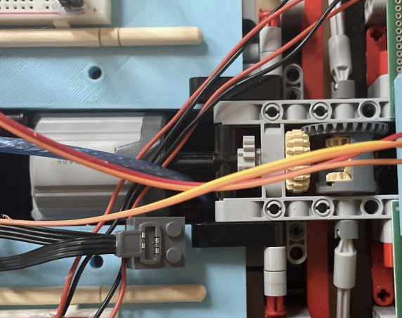

Figure 5: Mounting location of the Lego PF XL motor. The motor is mounted on the Left side, and the differential device is on the Right side. The PF motor provides almost a 1:1 ratio of motor to wheel power. Differential device evenly distributes the power among two universal joint axles on the right.

Both of the motors above are both ultimately connected to the Arduino NANO (The PF one goes through an H-Bridge module first) and receive motor commands straight from the NANO. The motors are just strong enough to pull the car around a smooth floor like in a kitchen, or sometimes even asphalt on the road. It is just inoperable on thick carpet. However, the functionality of the vehicle applies to mostly smooth surfaced areas. This will be in the limitations.

**Functionality**

**Limitations:** This car has some cool functionalities that allow it to interact with the real world. However, due to some constraints, some sensor limits, and some design choices. There are some limiting factors when it comes to the vehicle’s full functionality. I will list some of those functional constraints here:

**Physical Weight:** Because of the many breadboards on the system, the car is heavy (With respect to how much an RC car should weigh.) This causes us to design the motor assemblies around higher gear strength ratios causing the speed to go down.

**Back Lights:** The back lights are tied into the Auto Mode and Manual Modes. In real life, back lights are supposed to only turn on when decelerating or hitting the break pedal. Because they are hooked up tho this module. They are independent of the car’s forward and backward movements.

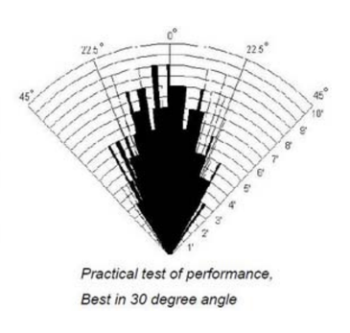**Blind spots:** Ultrasonic sensors have a rough visibility cone of 30°. This causes some blind spots as the sensors are only mounted on the 4 cardinal directions with respect to the local coordinates of the vehicle. Ultrasonic sensors are sonar devices so their trigger pulse is directional, and their echo needs to hear the specific trigger sound. When mounted on the vehicle, we get blind spots for the Auto-Reaction in the NW, NE, SW, SE directions. In addition, if something narrow (Like a pole) is just out of way of that 30° visibility cone, the blind spots may be bigger than anticipated. Figure 6 shows the visibility cone of a typical HC-SR04 Ultrasonic Device.

Figure 6: Visibility cone of HC-SR04

**Sound:** All cars have a horn, well unfortunately all this car has is some Ultrasounds that sometimes squeak when they take high frequency samples. Though the average person is incapable of hearing an Ultrasound squeak. Having a horn is one well known functionality of all default vehicles.

**Steering Angles:** Because of the weight, when steering at a very big angle, there are a lot of shear stresses on the wheels almost pulling on the rack and pinion rather than the shear being perpendicular. Once a parallel component of shear pulls the rack and pinion, at large angles, the car starts to become slower or even stalls. There are limits set in place for this in code, but there is a better way to design this mechanically.

**Reaction Bug:** Once you stop in front of an obstacle using the Auto-Reaction feature to stop automatically, control over the system stops and you cannot back up until the object in front moves. This bug can be fixed in code at a later date, but it reduces the functionality a bit.

**Ground Clearance:** Regulations require a significant amount of ground clearance to overcome speed bumps and debris. This vehicle has a lower ground clearance for its size causing it to stall on some small bumps. Not including that the motors are not powerful enough to pull the car. The weight to power ratio is low.

**Construction**

**Physical Layout:** The vehicle was broken into three different subsections. The draft subsections describe the layout of the model components. Level one is the vehicle under chassis, this was where all the motors, batteries, (Ultrasonics got moved up to level 2), and all the mechanical devices such as the rack and pinion, and differential gear would be. The second level would contain all the circuitry and one main microcontroller, and most of the wiring would be housed on this level. Finally on level 3, there would be a dashboard and some interactive buttons and a display. The controls got replaced by a level shifter and BLE server device.

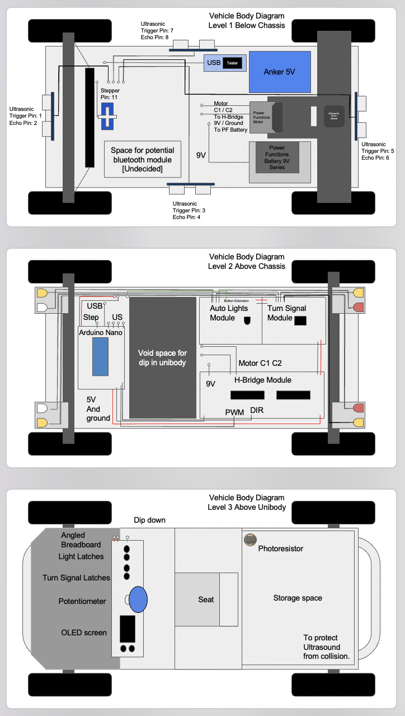As seen in Figure 7 to the left, these were the draft levels for the vehicle. Some changes came about for the final physical construction, but the “jist” of the layout remained the same. On the top there is level 1 with a 5V ANKER Charging bank connected to a USB testing device. This was to provide Circuit power, and the 9V Lego power bank on the bottom provided motor power. All the motors would be housed on the bottom level, just like they are in real cars. In the middle section we decided to put the lights. On the final physical prototype, the turn signals and main headlights/backlights changed sides. This was an aesthetic decision. You can see on the second level that there is a spot for all the circuit components. On the final design the circuits got moved up to the front. In reality on a full-sized vehicle, the circuitry would not be of a comparable size to the vehicle. All the circuitry on this vehicle can be minimized through PCB printing. Finally on the third level would be a seat, storage, and the dashboard. Also, the photoresistor in the final physical design was moved to on top of the dashboard. A lot of these features on the third level were omitted due to team dynamic changes and time constraints. These three main levels accurately describe the final model well.

Figure 7: All three levels of the vehicle.

**Construction**

**Construction Methods:** There were three main construction methods to recreate the goal of what was proposed in Figure 7. This was 3D printing, Lego Construction, and Breadboard Circuitry. The construction methods and what they were used for will be elaborated below:

**3D printing:** This provided the parts for the Ultrasound Brackets, the component mounting plate, and the dashboard mount. To print these components, I used the program UltiMaker Cura 5.5.0 in conjunction with SOLIDWORKS 2023. In Solidworks I would create a CAD model for each of the parts, then send a Wavefront file (.obj) over to Cura to parse it into G-Code under 20% infill. All three parts had been carefully measured out beforehand to make sure everything fits. The main design challenge was the ultrasound brackets which will be elaborated later. All the prints were done with 230°C Light Blue PLA filament on an Ender 3 filament printer. I have access to an ELEGOO Saturn Resin Printer, however that was not needed for this project as most of the prints are large structures. Though the brackets could have been done using resin. Below is the process of constructing one half of the component plate.

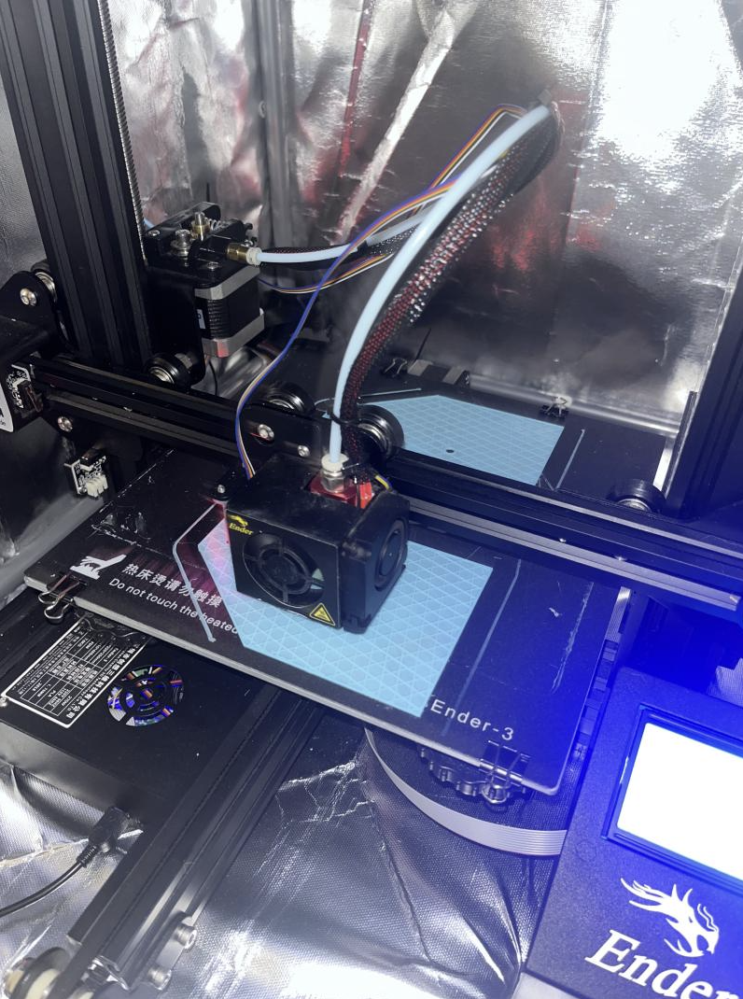

**Construction**

**Lego Construction:** This provided the entire mechanical chassis or base of the vehicle. Lego construction from Lego Technic Set 42029 – Customized Pick-up Truck, and Lego Technic set 42055 – Bucket wheel Excavator, provided the parts necessary to construct the majority of the lower hull. Most of the Lego pieces came from the 42029 set, where only the PF XL motor and Lego Power pack came from the 42055 set. So in reality, the entire 42055 set is not needed. Set 42029 already has some prebuilt rack and pinion and differential devices that were slightly modified to fit the new dimensions of the slightly larger vehicle.

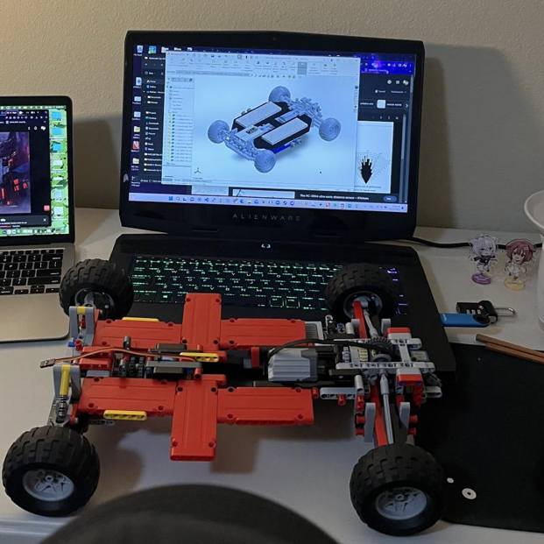

**Breadboards:** Breadboards were sort of the glue that held everything together. They also held the various circuits needed to do light and motor functionality. Standard 830 point and 400 point breadboards were used. Two 830 or normal size breadboards were used for the sides, while he 400 half size one was used in the front. One more 830 point was used for the dashboard. These breadboards provided the backbone of the Component Mount because that component was master modeled and had a slit down the middle. The breadboards, along with a couple chopsticks were used to keep the large 3D printed component plate ridged. All the circuitry was kept exclusively on the breadboards so that no wires are glued to any frame parts. Each breadboard was pretty well isolated. Perf boards seen in Figure 8 were used for just the lights.

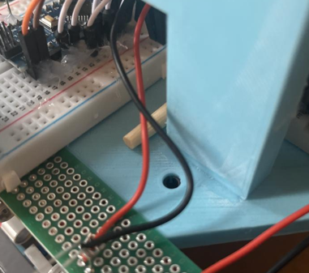

**3D model mounting and installing:** Because the 3d printed components were very well measured, they practically slid in and were almost fully compatible with the Legos already there. As seen in figure 8, there is a Lego technic pin placed inside the 3D printed component mounting plate. In addition to using Zip Ties to hold the 3D prints to the Legos, there was some Lego compatability with the 3d prints that allowed them to line up perfectly. You can also see one of the chopsticks used in figure 8 used to strengthen the plate. All the breadboards contained adhesive on their backs which allowed them to pretty much stick to the prints. Installing all the components was relatively simple due to the pre-planning and modeling.

Figure 8: Technic pin attachment.

**CAD Modeling**

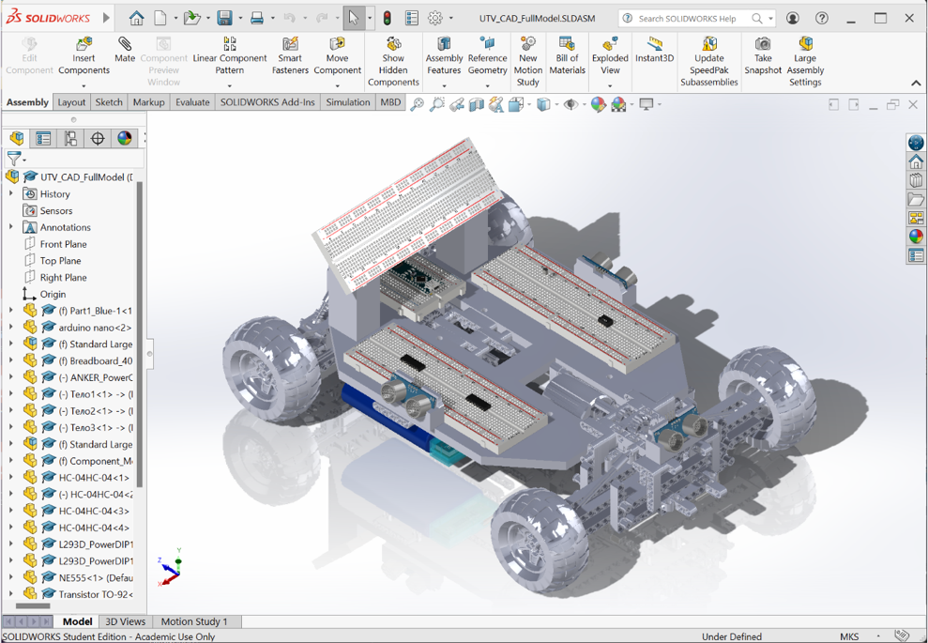

**Cad Models Produced:** Several CAD models were produced in different programs to create a complete model. As seen to the right, you can see the entire model. Not everything in this model was created using Solidworks. Below will be another program used to create a major component. I will mention the program Blender, however, it was not used to do any CAD modeling.

**Programs used:** Both programs LeoCAD and SOLIDWORKS 2023 were used to create different parts in the final model. Though the final model was rendered in SOLIDWORKS, it can be placed in a different environment such as Blender.

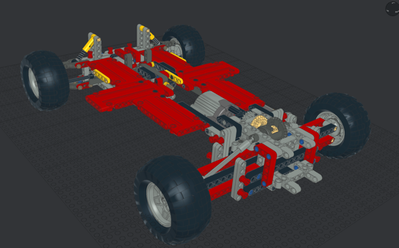**LeoCAD:** LeoCAD is a Lego CAD software that has 100% 1:1 component needed to recreate a model out of Legos. For this model LDraw was used as a Parts Library for LeoCAD. To the left in figure 9, we can see the entire Lego model that accurately represents the physical Lego construction used for the actual prototype. This model has a parts list stored in LeoCAD for future reference and recreation. For the model created here the components used and the actual final design had to change slightly to accommodate for unforeseen factors. Such as the suspension not being practical or strong enough, or some pieces in the back that needed to move for a battery.

Figure 9: LeoCAD model .ldr file.

**SOLIDWORKS:** Solidworks was used as a domain for all the CAD models used. In Solidworks an assembly was made containing all the files necessary to create the system. Specific components that were modeled by me will be elaborated on later on in the CAD modeling section.

**Blender:** Blender is a rendering system used to visualize ideas and animate. For some preliminary ideas on the project, Blender was used to better visualize them and get a sense of the project direction. For this project, Blender was not used for most of the CAD modeling processes.

**CAD Modeling**

**Files Used:** Several files were used to help aid in the visualization of the final project. All of these models came from Grab CAD.

* Ultrasonic: <https://grabcad.com/library/hc-04-1>
* Half Breadboard: <https://grabcad.com/library/breadboard-400-1>
* Breadboard: <https://grabcad.com/library/standard-large-breadboard-1>
* Arduino Nano: <https://grabcad.com/library/arduino-nano--1>
* H-Bridge: <https://grabcad.com/library/circuito-integral-l293d-1>
* NAND Gate: <https://grabcad.com/library/circuito-integral-l293d-1> (Same as H-Bridge Not necessary to get exact due to the model only being a visual representation)
* Transistor: <https://grabcad.com/library/transistor-to-92-2> (Represents Auto Lights Module)
* 555 Timer: <https://grabcad.com/library/ne555-3> (Represents turn signal)
* USB Tester: <https://grabcad.com/library/usb-usb-tester-1> (Not used in Physical Design)

**Parts Modeled by Hand:** Some files were done by hand because they were either not provided by a site on the internet or some parts are too niche.

* ANKER Power Core 10000 (I actually have one IRL, so I measured it using my Caliper.)
* Ultrasound Mount Block (Caliper used on HC-SR04 sensors IRL to create this.)
* Component Mounting Plate (Caliper used on Legos to get holes in right spots.)
* Dashboard Mount (Used to mount the breadboard in a dashboard angle.)

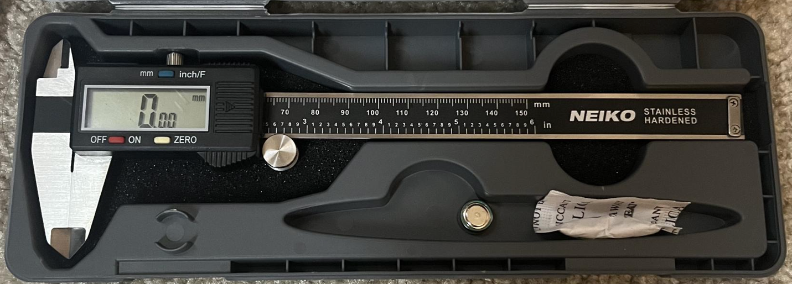**Digital Caliper:** This is the Caliper I used to hand model all the 4 parts mentioned above. The crazy amount of accuracy on this device allowed me to perfectly model every dimension for the three 3D printed parts. I know this isn’t a place to sponsor things but getting yourself a NEIKO Digital Caliper will allow you to create some of the most refined 3D models that will fit any component with ease. The high accuracy tolerances this device provides allowed me to also create Lego technic pin holes in the component mounting plate for easy mounting onto the Lego chassis.

**CAD Modeling**

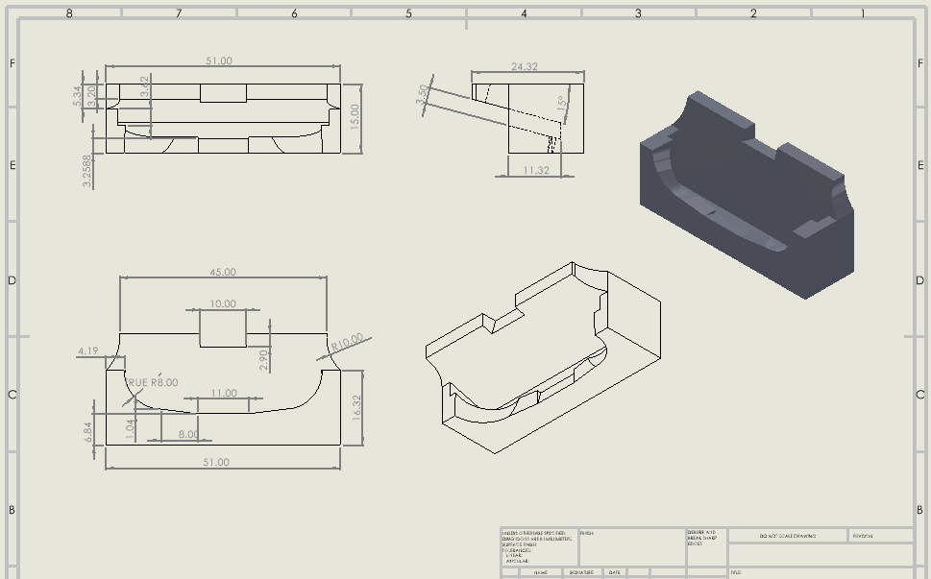

**Techniques used for modeling:** I believe the most intricate model came from trying to figure out how to mount the ultrasounds onto the vehicle. Due to the 30° cone of visibility, I needed to raise the Ultrasound Sensors up by 15° so that they would not have ground interference. I will list some important modeling techniques that allowed the three models to be possible.

**Tolerances:** PLA filament is not infinitely thin. When a printer prints, the PLA expands a bit from the nozzle head. On a macro scale this is all negligible, but on a smaller scale, this can cause problems. And some PLA are extremely hard to post machine, especially if the tools don’t fit into the notches of complex objects. When measuring the outer surface of an object, place an extra 0.01 or one significant figure of the most accurate measurement. This is called tolerancing. For holes, you can measure the diameter, and then add 0.02, if you are using a mm ruler, adding 0.1 may be safer. This can apply to how well the PLA filament expands. If your measuring tool is way too precise, you may need to have a default tolerance. These tolerances saved me from having to post machine a slot or hole on my designs. For real world machine shops, putting crazy accurate tolerances on a surface that doesn’t need it will cause machining to take much longer and will cost more. Use tolerances where needed, and you can increase the tolerance a lot for outer surfaces that don’t need to be precise.

Figure 9: Drawing for the Ultrasound Mount Block

**Real world Measurements:** Having a physical object with you to measure is a lot better than going off some measurements online or a picture. When modeling to hold an item, model around the item shape using measuring tools. For the Ultrasound Mount Block I made, I did that for the entirety of the sensor, and the result allowed the sensor to fit in snugly. Instead of eyeballing it using pictures and written dimensions, using a ruler or caliper can really refine the process. The good thing is that 3D printers don’t care how complex the shape is, as long as it is printable.

**Model with the future in mind:** Many manufacturing processes are expensive and take forever. It is extremely important to get it right first. Spend a lot of time brainstorming what the model needs to accomplish before even designing it. For instance, the component mounting plate created here had to have edges that pull in at the sides to give enough clearance for the rack and pinion to rotate. The plate had to be thick enough to support the bending moment of the car as it wanted to sag in the middle, etc. Some of these factors if not addressed beforehand would waste a lot of time on the post processing of the part.

**Boolean Modeling:** Blender has these things called Boolean Modifiers. Essentially they are like shapes cut out. For the Ultrasound Mount block, create a convex hull around the sensor. Then in your head imagine placing that convex body inside a standard rectangular block. Subtracting the intersection of the two areas is Boolean modifying. It saved a lot of time modeling with this in mind instead of creating a body around the sensor. This also can apply to a method of master modeling, where cutting out sections and constructing pieces after saves time.

**CAD Modeling**

**Design Reasoning:** There are a couple of design choices made throughout the project that may need a bit more in depth explanation. I will explain the design choices here:

* **15° upward angle on the Ultrasound Blocks:** As mentioned before the ultrasounds have a 30° optimal viewing angle. Well there is a possibility of measuring greater than that angle but it is unlikely. The angle was chosen to be 15° because when we bisect the optimal viewing angle, we get 15° of depression angle. We need to elevate each sensor by 15° upwards so that their effective view in their respective direction is more or less level. This is to stop feedback looping on the ground. Ultrasonic Sensors are sound based devices and cannot control where the sound goes and how it bounces off. To reduce the amount of ground feedback error, this tilt was designed.
* **Component mounting plate in two parts:** The component mounting plate is exactly 25cm x 21cm x 0.8cm convex hull. The Ender 3 print bed is about 23.5cm x 23.5cm. The longest edge of the component mounting plate could fit onto the plate barely as seen on the image on page 9. To be able to print the plate, the component mounting plate was master modeled to be split down the middle of the 25cm side to allow for both halves to be mounted onto the plate. Unfortunately, this split is the moment force direction of the car and had to be stabilized. The more important direction is the 25cm direction because that is the length of the car. Naturally gluing the two halves together on the moment force direction meant some extra components were needed, but there was simply nothing else I could do to master model the 25cm plate side on my inadequate printing bed size.
* **Why is the component mounting plate on top of the Legos?:** This design idea came from the fact that breadboards have adhesive. Structurally I believe the mounting plate could have done better mounted underneath but due to the ease of construction and reassembly, the plate is mounted on top.
* **Why were the breadboards moved forward?:** So yes indeed the previous plan was to back-mount the breadboards to leave a middle space for a potential seat and pedals. The main issue was weight distribution. With the current setup, the weight is almost perfectly balanced such that there is not too much normal force strain on the motors when they have to rotate the wheels. With the weight distribution fix, the vehicle is much easier to carry around and has a bit easier time moving around itself.
* **Why the Zip Ties?:** Zip Ties provide an extremely important aspect of prototyping, disassembly and reassembly. Supergluing the plate to the Legos would make the Legos impossible to repurpose and would make rapid fixes and changes impossible. The point of rapid prototyping is to allow for active change to fix technical limitations and issues. Zip Ties are perfect for extremely strong holding forces while being passive to the materials it is holding. This is the main way I connected the batteries to the hull.

**Circuit Design**

**Circuits:** Circuits are a crucial aspect of any project. Specifically for this project it was a mandatory requirement. This was because 11 pins of the Arduino NANO are being used by several different components and sensors. (Specifically, 8 for the 4 Ultrasound Echo/Trigger, and 3 for Motors) To alleviate the use of pins on the NANO, a couple Arduino independent circuits were constructed. These included the Automatic Lights Circuit, the Turn Signal Circuit, and the H-Bridge Circuit. These three circuit modules will be explained in great depth below.

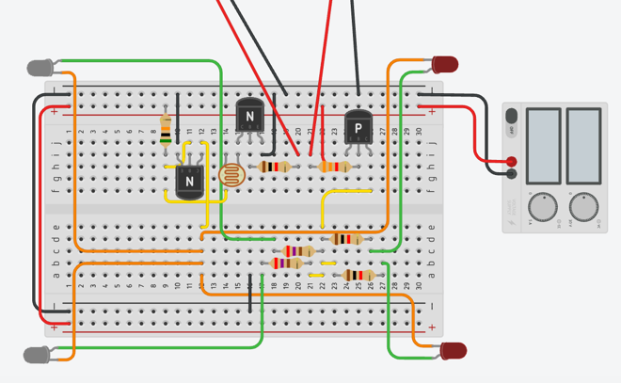**Automatic Lights Module:** This circuit was to handle the change in brightness and allow for digital control over what lights are on and which are using a photoresistor to turn on and off. There are two digital switches for this circuit, one governed by a high side transistor switch for power (Manual Mode) and one low side transistor switch for the brightness circuit (Auto Mode). In figure 10, the high side transistor switch is on the right and the low side transistor switch is in the middle. The transistor on the left does light detection. The total circuit has 4 possible states: (A on M on, A off M on, A on M off, A off M off) Keep in mind (A on M off) and (A off M off) are the exact same state visually because of Manual Mode precedence over Auto Mode. So how do these transistor switches work?

Figure 10: Tinker CAD setup for the module.

**High Side Transistor Switch:** Transistors have 3 legs, one for Collector, Emitter, and Base. To hook up a high side transistor switch you need the following configuration: Emitter pulled high, Collector as the output, and Base as the control. You can turn on and off the High Side switch by passing *Resisted* current through the base. When the base is Low or around 0V the switch will let current through the Emitter and out the Collector. When the base is High or around the same as the Emitter voltage, the Collector pin stops letting current through. This is essentially how a high side switch works.

**Low Side Transistor Switch:** For this configuration hook up the transistor in this way: Emitter pulled low, Collector as the “output”, and Base as the control. This is the opposite to a High Side transistor switch and the way you control it is different too. When the Base is pulled high, by-passing *Resisted* current, or to the same voltage as the circuit source, the switch turns on and lets current pass through the Collector to the Emitter. When the Base is Low, the switch is off. These transistor switches are essentially like physical switches but controllable through voltage levels. (GPIO pinouts can control this base voltage nicely.)

**Circuit Design**

**Voltage divider brightness circuit:** To allow the front lights to react to brightness a special circuit was constructed. So just like how a Low Side transistor switch works, this circuit does the same thing. A resistor and photoresistor voltage divider circuit need to be constructed first. The first resistor is a 50 kΩ resistor, and the second is a photoresistor. A photoresistor has an inverse relationship between resistance and brightness. The formula for a voltage divider circuit is as follows:

$$V_{out}=\frac{V_{s}*R_{2}}{(R_{1}+R_{2})}$$

Vs is our source voltage always held at 5[V]

R2 is our photoresistor Range (1kΩ to 350kΩ) (Light to Dark)

R1 is our normal 50kΩ resistor. (This can be changed out if the lights are not tuned to your photoresistor)

In the configuration for the darkness detection circuit the Vout is connected to the Base of the NPN low side transistor switch. The Emitter is pulled low, and the Collector is going to the front two lights.

Now we can figure out how this circuit works. Suppose we are in complete darkness. R2 is our photoresistor which is very high maybe it is 250kΩ for instance. Plugging that into the voltage divider formula Vout = 4.1667 [V]. From the knowledge of a Low Side Transistor switch, if the base is pulled by *Resisted*current to high, or close to the source voltage, the switch is essentially on. This is why the lights turn bright when it is dark.

How about when it is really bright? Suppose we are shining sunlight onto the photoresistor. R2 could be a value of 2 kΩ, because we know a photoresistor has an inverse relationship between resistance and brightness. If we plug this value into the voltage divider equation:

Vout = 0.1923 [V]. Recalling that for a Low Side Transistor switch, if the base is pulled low, the switch is off. This is why when it is bright, the lights turn off.

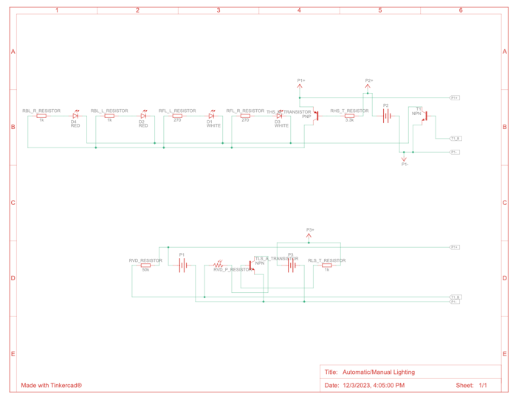

Now what makes this much better is that a voltage divider is not just either high or low. For a range of resistance values the photoresistor can take, a range of voltage values come out. The good thing is that the voltage can’t be amplified. And since transistor switches aren’t really bistable switches, (transistors are powerful in this way), it can do analog brightness change without any digital circuit at all. Isn’t that cool. To the right is the diagram, which will be provided in the repo.

**Circuit Design**

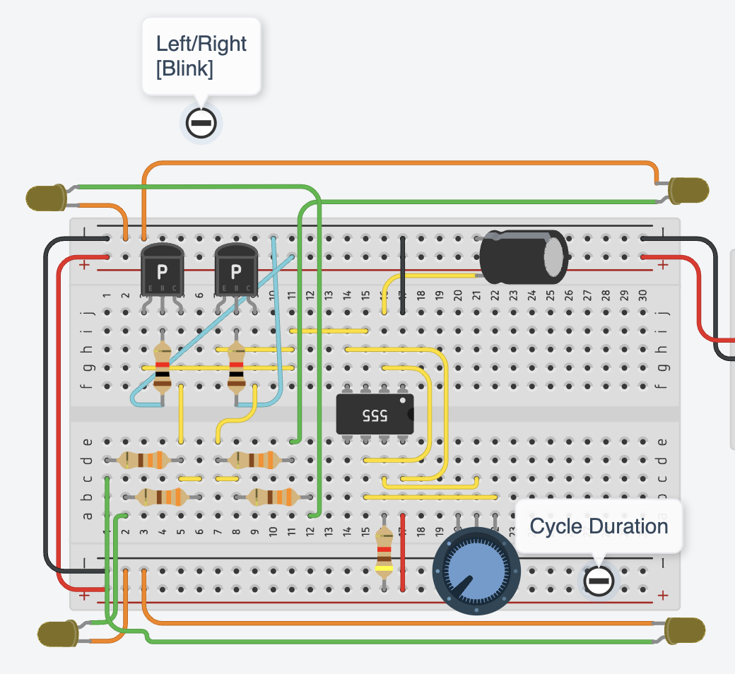**Turn Signal Circuit:** This circuit’s job was to unify a turn signal pattern frequency to two pairs of lights on either side and allow it to be controlled by just a couple switches. To the right is the full setup for the module. In the module you can see several High Side Switches used. The Emitter of each transistor is connected to the pulse from the 555 circuit to the right. This is essentially the input for each high side transistor switch. The collector of each switch is sent to each of the 4 LED. The left switch goes to the left side, and the right switch goes to the right side. When we pass *Resisted* current into either of the Bases of the transistors we can turn on and off the influence the 555 has on each of the lights because the signal passes right through the Emitter to the Collector. In the previous section I didn’t explain what happens if the Emitter isn’t pulled high in the high side transistor circuit. If that happens, there is no current going through the Emitter to the Collector so the switch is off even if the base is pulled low. Now how does that 555 circuit work?

Figure 11: Tinker CAD setup for the module.

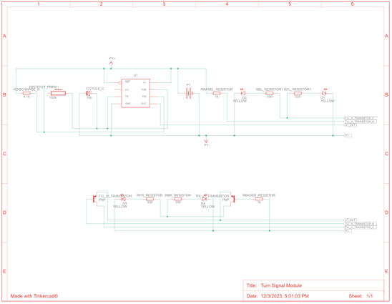**555 Timer circuit:** The 555 timer chip is a universally known TTL chip known to satisfy almost all your clock needs. We take the OUT pin of the 555 and connect that to both the left and right side. By doing this the frequency for both sides is exactly the same. We connect TRIGGER to THRESHOLD on the 555 to allow the timer chip to not need an external trigger pulse because the comparator behind the trigger pin does it for us. Connecting POWER to RESET allows the timer to stop the oscillator when the circuit source voltage is gone, and allows for automatic setting reset to high to restart the oscillator. For this circuit DISCHARGE and THRESHOLD are connected to a potentiometer, this allows us to choose how fast and slow to charge and discharge the capacitor. Discharge is also resistively connected to power. Lastly the positive terminal of the capacitor (That the 555 uses to make oscillations) is connected to the trigger pin of the 555. Now what this circuit does is somewhat confusing but in essence, it fills up the capacitor to the upper right to a certain threshold, which we can set by using the potentiometer. Next the 555 sets out to high while the capacitor is charging. Once the capacitor reaches a certain threshold, the 555 then discharges the capacitor and sets out to low. This cycle repeats as long as there is power. The 555 is able to do this because it has some comparators (op-amps), a transistor, and a T-Flip-Flop. We can use the out pin to control any device that needs a steady clock signal. A full diagram for this circuit is provided in the repository as well.

**Circuit Design**

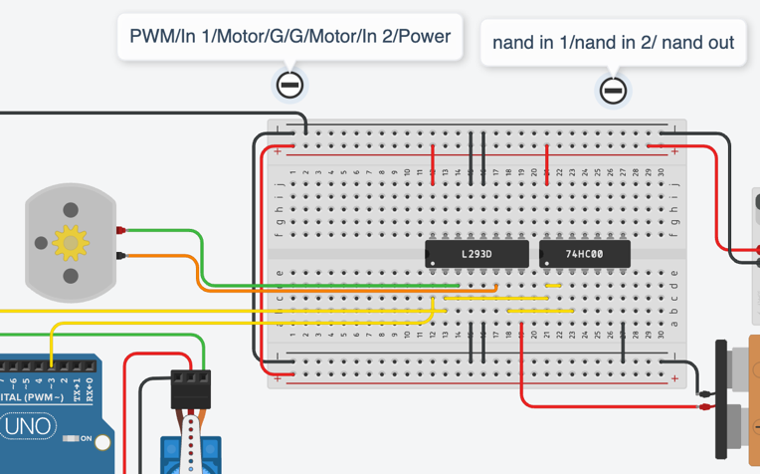**H-Bridge Circuit:** The motors can’t simply be controlled by a couple GPIO pins, unless you do some funky coding or some weird transistor switches. To save all the hassle, and H-Bridge chip called the L293D was used in conjunction with a 74HC00 TTL NAND gate. Now I love working with TTL stuff, and any chance I get to use some logic gates is pretty fun. The purpose of this circuit is to allow me to drive a motor in two directions and control the speed. Speed control can be done using something called PWM modulation which is in the digital world, a way to digitally represent analog signals with digital outputs. This is important because the NANO can read analog but can’t write analog. And for the direction control a NAND gate is used. To the right in figure 12 is the wiring setup. Below is an explanation of the wiring:

Figure 12: Tinker CAD setup for the module.

**H-Bridge chip L293D:** For this chip we hook up the pins as follows:

* Power 1 to 5V
* Ground x4 to ground
* Enable 1 and 2 to PWM signal from NANO
* Power 2 to 9V (Make sure this is isolated)
* Output 1 and Output 2 to C1 and C2 of a DC motor.
* Input 1 to Arduino NANO
* Input 2 to Output 1 from NAND gate

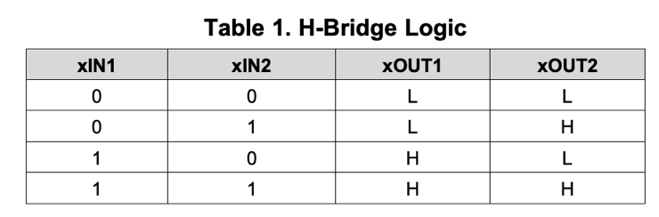What this chip does is pretty cool. So it takes your 9V, in reality this can be up to 38V which is enough to fry any circuit, and by using the Enable 1 & 2 as well as the Input 1 and Input 2 can drive the DC motor connected in any direction at any speed. PWM signals are generated from the Arduino to tell the H-Bridge chip what speed to move the motors at, and Input 1 and Input 2 are part of a Binary table. What we are interested in is the two middle cases. This allows motor direction control. To control these pins in this way, we can use a NAND gate.

**NAND Gate:** The NAND Gate is a TTL logic gate that takes two inputs and negates them. The gate has its own inverter circuit. So in this project we use it to hook up Input 1 to both Input 1A and Input 1B on the NAND gate. Then the Output 1 to the Input 2 of the H-Bridge circuit.

**Circuit Design**

**TTL Logic magic:** So with just a NAND gate and one voltage source, we are able to change Input 1 and Input 2 of the H-Bridge to be the middle states of that table. Well how does this work?

* Let’s consider the case when we want to drive forward. On the NANO we can set a pin called the Dir_pin_out as pin 10 on the NANO, this pin is either high or low. Now this pin is set to LOW first to mean Forward. From the setup Input 1 of the H-Bridge is now LOW since this is coming from the NANO. Next the LOW state is fed into Input 1A and Input 1B at the same time on the NAND gate. Since the NAND negates, it will pass out HIGH on the output 1. This output is then fed back to Input 2. Keeping track of things, we just set Input 1 to LOW and Input 2 to HIGH with a single LOW signal from the NANO.
* Now let’s consider the case where we want to drive backwards. We can set that Dir_pin_out to HIGH now. Input 1 is now HIGH, and because of the NAND gate Input 2 is LOW.

These two states match exactly to the two states in the middle of the H-Bridge Logic table. With one signal we can change directions because of the NAND gate. But now you must be thinking, how does PWM make us control motor speed?

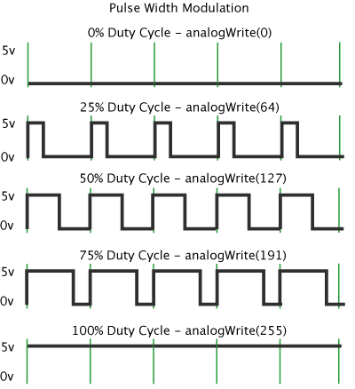**How PWM works:** PWM stands for Pulse Width Modulation and is a way to represent analog signals as digital pulses. A PWM signal has two types of properties, a frequency and a duty cycle. For the NANO, pin 11 is being used for PWM and the frequency at which this PWM signal is done at is 490Hz. To the left in Figure 13 we can see how the PWM signal is being generated. The green bars represent a fixed frequency, this is that 490Hz that stays constant. The thing that makes PWM special is duty cycle. The duty cycle of a signal is defined as a ratio of the time on vs the time off. Essentially this rapid turning on and off induces a special average voltage in the wire. This average voltage can be used to drive DC motors. This is good because the average voltage can be different from the HIGH voltage and LOW voltages. For the NANO I can pass in a PWM signal to pin 11 and it will carry that signal to the Enable 1 & 2 pin of the H-Bridge which then magically does some stuff to allow the 9V to do the same thing for the motor. The important thing is that PWM and directionality are independent. PWM is just the absolute value of speed. So, for the circuit we can treat speed and direction as separate controls.

Figure 13: PWM diagram for NANO.

**Circuit Design**

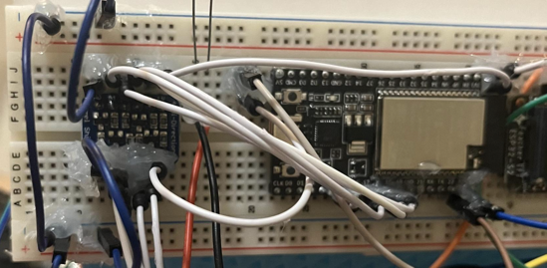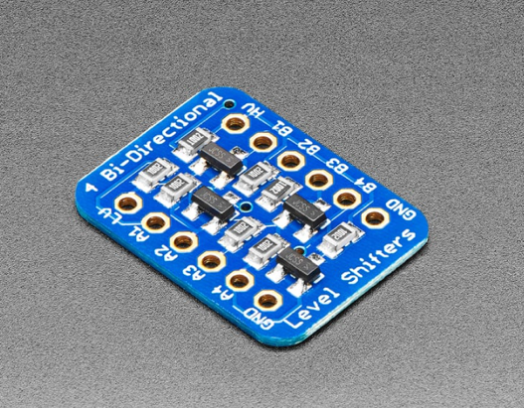**Level Shifting:** So, the funny thing is that the purpose of the circuits was to reduce pin usage. The addition of using high side and low side transistor switches reintroduced that drawback. Luckily there is another module mounted to the vehicle to handle these 4 switches. The ESP32-WROVER-E Devkit microcontroller used for the BLE server is capable of doing pinouts too. So on one side we’ve solved the pin issue with the NANO by adding a bus to the ESP32, but the problem is that the ESP32 is a 3.3V board. If you recall back to the high side and low side switches, you can only turn them off or on if you set their bases to high respectively. High in the context of a transistor switch is the source voltage, and the source voltage used for the entire circuit is 5V. So if we passed a 3.3V signal into one of those switches, they wouldn’t turn fully off or on. To fix this a Level Shifter circuit component was added. This little guy in figure 14 is a 4 channel I squared C safe, Bi-Direction Logic Level Converter. That is a mouthful but it basically converts any Lower Voltage source, to a Higher Voltage source. With this we can pass in 3.3V to be bumped up to 5V. With this we can allow the ESP32 with it’s 3.3V lines to control those transistor switches. So you can see that in figure 15, the level shifter is being used to raise the 3.3V output from the Devkit, to 5V to be able to interact with the transistor switches. On the physical model all those white wires are collected together and is like a bus for all the light switches. You can turn on and off these lights if you replace one of the wires at the transistor switch position and feeding 5V, with extremely low AMPS, into that transistor switch wire connection. Each of those wires is connected to a base of a high or low side transistor switch depending on the circuit.

Figure 15: Adafruit Level Shifter with the ESP32-WROVER-E.

Figure 14: Adafruit Level Shifter

**UART Chain:** Specifically for this project, the serial protocol used is UART Serial. Each of the Microcontrollers used: The ESP32-WROVER-E Devkit [BLE], Arduino NANO [Nano], and ESP32-S2 Feather [OLED] are all talking to each other through UART TX and RX. Below is the chain of UART which is one directional:

BLE

Nano

OLED

TX1 -> RX

23 -> Rx0

**Light control Motor Control Serial Display**

**Programming**

**Programming** is one of the most crucial parts of making everything function. Sure some of the circuits I designed are programming independent, but since they are now linked through transistor switches, we need something to be able to help us interact with them. This includes the motors and the ultrasonic sensors too. Three microcontrollers and one BLE delegate device are used to provide most of the functionality in the project. The 4 programs used provide many ways for the vehicle to interact with the real world as well as be able to use all its lights, motors, and sensors to be able to do things itself. The 4 programs that I will go over in this section are the BLE Server, Automatic Reactions, OLED Serial Mirroring, and the IOS Application. Each device has unique code which serve a special purpose in the project.

**BLE Server:** The BLE_server is run on the ESP32-WROVER-E Devkit. This program’s task is to receive packages from your phone and place them onto the UART serial line. Another task this program must accomplish is to control the lights. Let’s go over exactly how the code works:

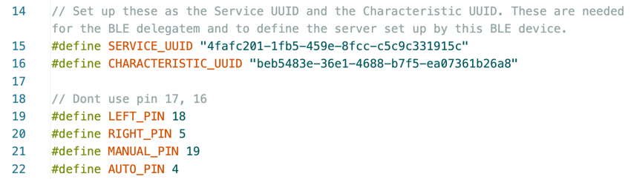

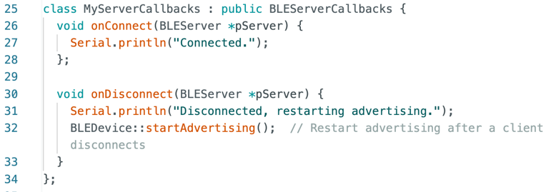**Setups:** In the first few lines the program sets up some variables. The first two are a service UUID and a Characteristic UUID. These are universally unique identifiers that are 16 bytes, they are helpful identifiers for our BLE network broadcasted by the vehicle. Next we are defining the pin locations on the board that are connected to the level shifter described previously. These numbers correspond to each of the Modes described previously. We are just defining variable names now; nothing has happened yet.

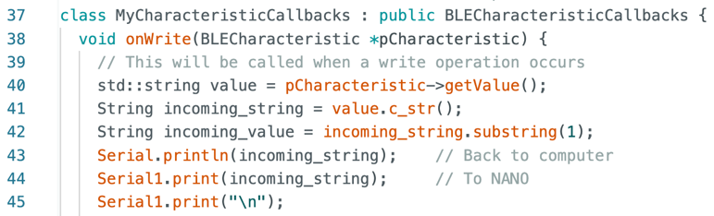**Callbacks:** Next we set up two callback functions. Their purpose is to execute when we get a change in either the server or the characteristic. In the server callback we set up two more functions. One prints a line when we are connected. The other prints that we are disconnected, but also restarts the advertising. This allows the device to be discoverable again if it disconnects. In the characteristic callback we take a string from the changed characteristic. We take the substring from the second character to the last and set that as the value. Next we are sending both strings over to both the computer but also to the NANO. We need to print a newline to make sure the old commands aren’t getting mixed up. These two structures are called callbacks and they are special, instead of activating like an if statement in a while loop, they only happen on a specific event. We can do certain commands when these events happen, such as on disconnect, advertise again. Or on write in the BLE characteristic, we can take the string and do some things to it.

**Programming**

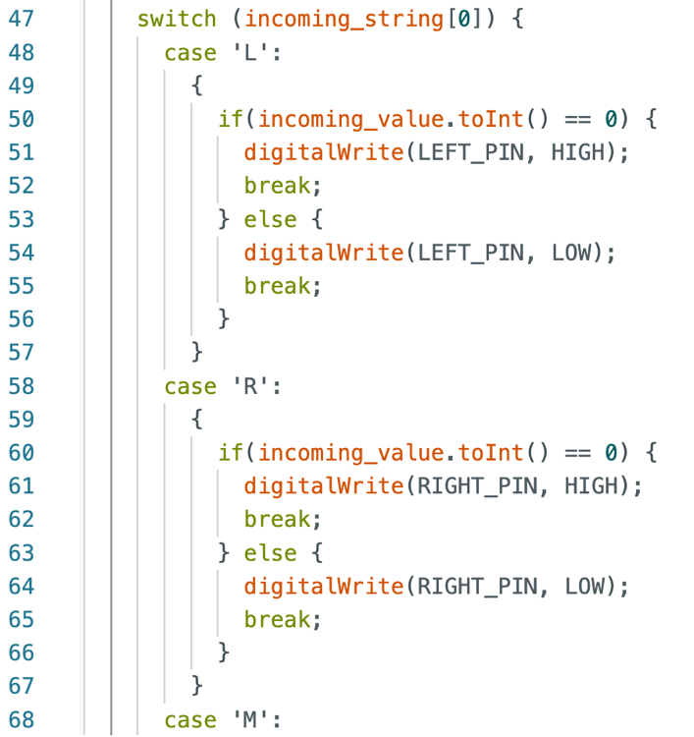

**Switch Case:** Inside the characteristic callback, we can do a switch case on the “Tag” or the first character coming in. Remember from the first part in the controls section, when you send something in the Text Field, you need a tag. When the IOS app modifies the characteristic, we can read that tag by taking the first element in that string. That single character is the “Tag” and can be used to identify which thing we need to do. A couple of cases are shown to the right but essentially they just write high or low to each of those pins defined in the first part. Externally that level shifter and those transistor switches are doing their job to get the lights to match what the pinout on the Devkit is doing. The switch case handles just the lights, there will be one for the NANO for motor control.

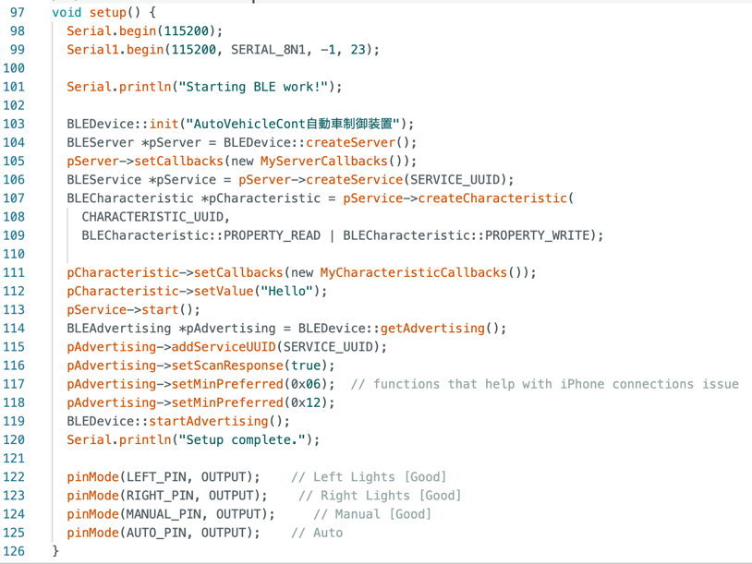**Void Setup BLE server:** In this section I setup the BLE server as well as a plethora of other things. The BAUD rate is just set to 115200 for both the computer and the NANO. After “printing Starting BLE work!” I set up a network name called “AutoVehicleCont自動車制御装置” or “AutoVehicleContJidoushaseigyosouchi” It is elaborate so that on the advertisement list, it is easily identifiable. I then start up a server and then its callback. After that I create the service using the service UUID defined before and then create a characteristic with its UUID. I then allow the characteristic to be read from and written to. Writing for the Phone and reading for the BLE server microcontroller. Then the characteristic needs a callback for when it changes, and then I can just shove some random value in there for now “Hello” works. Once all that is setup I can start the BLE service. Then for the advertisement I can add the service UUID that can be used by other devices to find the BLE server easier. Then for advertising I can set a couple things the set scan response is true so we can get that on the phone when we need to scan a lot. The setting MinPreferred helps with IOS stuff, they aren’t necessarily that important. Then I start the advertisement and print “Setup complete.” After BLE is nice and Happy I can set those pins to their correct pin mode. At the bottom not included in this documentation as an image is a void loop with only delay(2000); inside it. This is because everything is defined as a callback or a setup. The delay paces the microcontroller, so it isn’t just doing a crazy number of loops per second for nothing.

**Programming**

**Automatic Reactions:** This program called Arduino_Auto_Reaction is written for the Arduino NANO and is meant to give the NANO the ability to pass on serial, read and interpret serial, as well as control the motors. Let’s go over how it works:

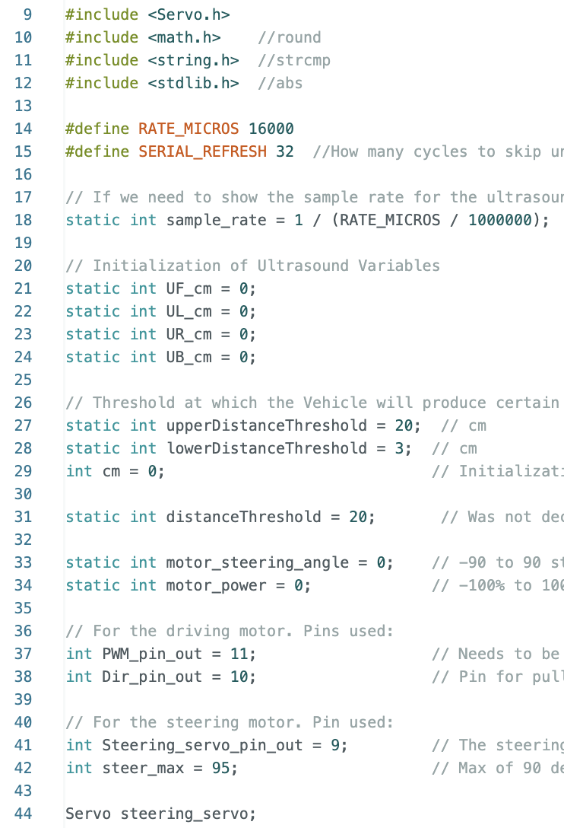

**Setups:** In this bit of code, a bunch of stuff is set up. I first import some libraries I will be using, to the right of them is the specific function I will be using from each one. I then define a rate in microseconds (This is for how fast the program runs), and a second one for how often to refresh deliver the serial to the OLED screen. These rates are important to how useful the Ultrasounds are, to the readability of the OLED. I then set up a couple variables such as the Ultrasound integers, the distances at which the ultrasounds start reacting, a couple variables for steering and power. At the bottom are the pin numbers and a steering limit variable. The threshold and steer_max variables are free to be changed. They can be used to fine tune the system. Not all the variables defined here are actually used because of some code compatibility issues when merging. Defined in code but not shown here is a readUltrasonicDistance function. This function was provided by a tinker CAD tutorial that automatically handles distance measurements through the trigger and echo pins.

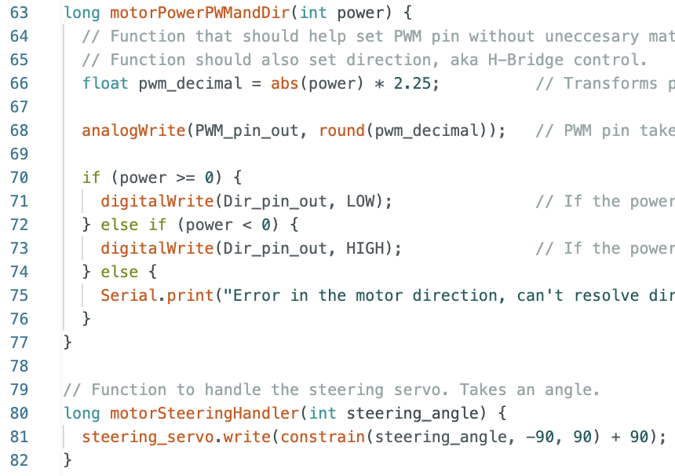**Motor Functions:** To the left are two motor functions. The one on the top takes in an integer called power, and then scales it to PWM size. This is assuming you put 0-100 as the power. Then if power is some negative or positive integer, we can write to that Dir_pin_out to tell the H-Bridge to turn around. For the second function, we can pass in a steering_angle and through the constrain function we can constrain it to a range of -90 and 90. The steering max still needs to be inputted. And steering scaling for different steering constraints needs to be fixed, this is why they are still currently set at 90. Code changes will take place to fix this error.

**Programming**

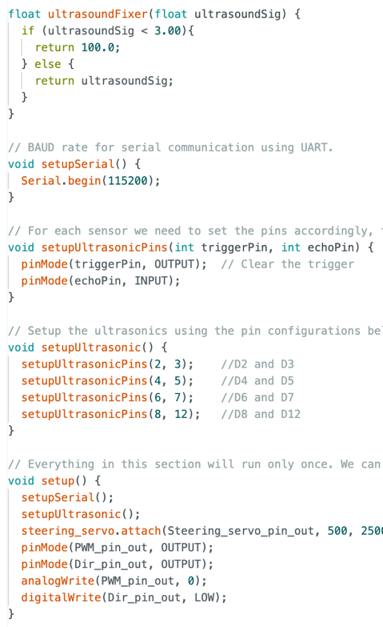

**Ultrasonics:** So through testing, I’ve noticed, when I had my ultrasonic sensors hooked up to the oscilloscope, they were passing 0 as a value for anything too far away. This is generally bad because of how the reaction portion works in the logic part of this program. To fix this, when the ultrasound passes a number that is too small, smaller than the min range on the documentation for the HC-SR04, then we can just set this value to 100. Else we don’t touch the current value. As seen before the BAUD rate is the same if all the devices are on the same UART chain. I can then set up the trigger and echo pins for the ultrasonics with the setup ultrasonic pins and the setupUltrasonic void setup later. In the void setup, I call everything and make sure all the pins are in the write initial states and are defined properly. Once everything is set up, we can start doing logic with all the devices.

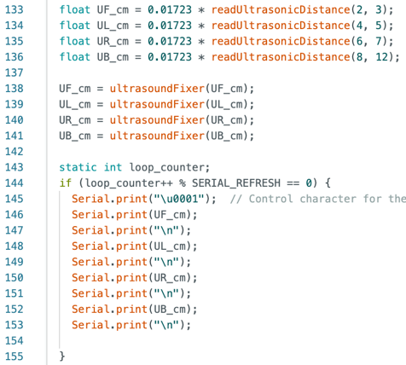**Ultrasonic reading:** To the right is inside the void loop, we can call the read ultrasonic distance function provided by tinker CAD to grab ultrasound values from all 4 sensors onboard. We can also scale them to get proper [cm] measurement. After that I can pass all 4 into that fixer function I made to filter out any sensor saying 0. Inside that if statement, we are controlling the rate at which serial is being printed out for the Ultrasounds. This is because the ultrasounds normally operate at around 40Hz, which on the OLED screen looks kind of bad. To fix this a rate was set so the OLED could properly clear and refresh the screen.

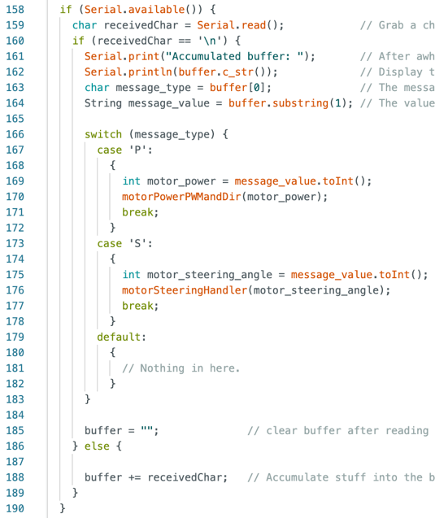**Serial Interpretation:** So, while running, the NANO is receiving serial from the BLE server module through the RX0 line back in the UART chain section. We can do the exact same thing the BLE server code does on the characteristic, on the serial in for the NANO. The only problem with this is that the serial comes in one character at a time, so to fix this we can add this to a buffer. Notice the else statement at the bottom. Any received character that isn’t a newline is getting appended to a buffer. This is why we needed that newline in the BLE program. Once we get the full string we can then start interpreting it with a switch statement. Once done interpreting we can then clear the buffer with the “” empty quotes. Just like the BLE deciding the lights, the reaction program can interpret the P and S tags to write to the motor and steering functions.

**Emergency Protocols:** I the author Nathan Fikes, did not participate in the construction of this section. The section belongs to my partner Thomas Tran who worked on the logic. This section of code is very lengthy and will not be displayed here. The basis for the construction of this section will be elaborated on. Essentially within the main loop of the program, we need to both interpret control to the motors inside the Serial Interpretation section; however, we can call the motor functions again if certain criteria are met. These criteria are mainly potential collisions detected by the Ultrasound sensors. For our reaction logic we wanted the car to do several things on several conditions:

* While cruising, turn left when an obstacle is too close to the right.
* While cruising, turn right when an obstacle is too close to the left.
* While cruising, speed up when an obstacle is approaching the back.
* While cruising, slow down when an obstacle is approaching the front.
* While stationary, move forward when there is a dynamic obstacle in the back.
* While stationary, move backward when there is a dynamic obstacle in the front.
* While stationary, perform a “Jack Knife” in the opposite direction of the approaching dynamic obstacle.

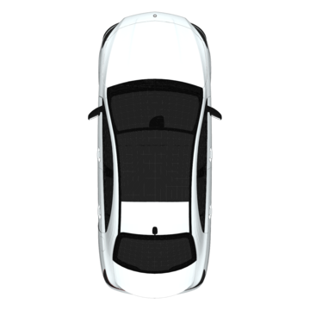So what exactly is an Jack Knife in the sense of cars? For Trucks it means to turn such that the trailer and the car are decreasing their angle. It is usually applied to when truck drivers crash. But the movement the truck does is similar to how a car would move its edge away from the moving obstacle. This can be applied to cars because a Jack Knife is a way to turn a vehicle such that a side is going away. Imagine the two cars below. The car on the left represents our vehicle. The car on the right is a dynamic obstacle. When moving forward, or the same direction of the bottom blue arrow, the way to get the right edge of the car away from the obstacle is to turn the wheels to the left. This allows the nose of the car to follow the curved blue arrow. When driving backwards, the case switches. When driving backwards we need to turn the wheels to the right in order get the nose of the car to follow the curved red arrow which increases the distance from the right edge to the obstacle. The figure below shows intuitively what you would do to avoid that obstacle.

Figure 16: Representation of one of the reaction decisions the vehicle must make.

**Programming**

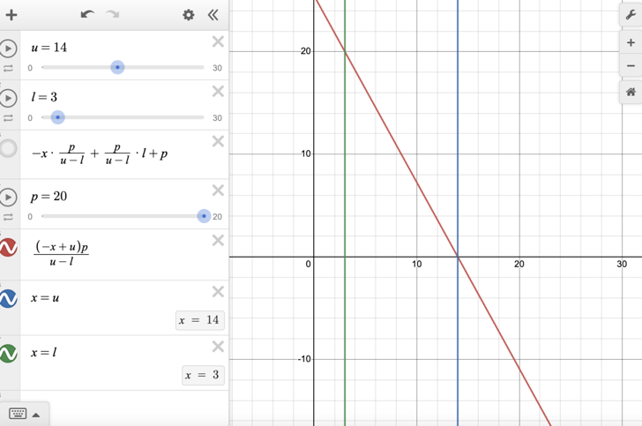

**Governing Function:** So in order to be able to modify the motor functions with the Ultrasounds we must create a function. This function parametrizes the influence on the motor, Y-Axis, with the distance read by the ultrasound sensor, X-Axis. To achieve the desired result, we want the motor to be powerful when we are receiving close measurements on the Ultrasounds. This means that there is an obstacle next to one of the sensors. Else when we are not detecting any measurements we can say the function is nonresponsive. This was included in code as if the function was turned off like a Heaviside past the threshold distance by using if statements. For each case where the car would be looking at ultrasound sensor data, the vehicle made the right response depending on the situation using this governing function to control the motors through influence values.

**Rate:** This will be elaborated on in a different section but the rate of doing all these commands is set by this delay function at the end of the void loop in the program. It essentially paces the program based on a rate set up a the top. Without this rate audible screeches can be heard from the ultrasound sensors trying to sample at higher frequencies.

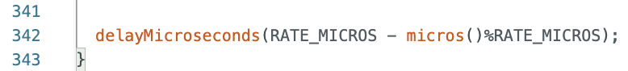

The entire Arduino reaction program is in the middle of the UART chain, so it needs to read and resend the packaged serial over to the OLED device which is the last module in the chain. All the delays help make sure that this isn’t being done too fast so you can visually read the commands coming into the OLED screen OLED Serial Mirroring is the second to last program which is relatively simple.

**OLED Serial Mirroring:** This program called Adafruit_Feather_Serial_Reader has the sole task of taking whatever serial it sees on its RX pin and printing it on the screen. In the previous program I didn’t mention that the serial print for the Ultrasound values starts with a UNICODE escape character “\u0001”. This character cannot be printed as a letter on the screen, rather it is a terminal command. On a UNICODE list you can see what it means but in the OLED program it is simply used as a refresh character. I will walk through the entirety of the program on the next page:

**Programming**

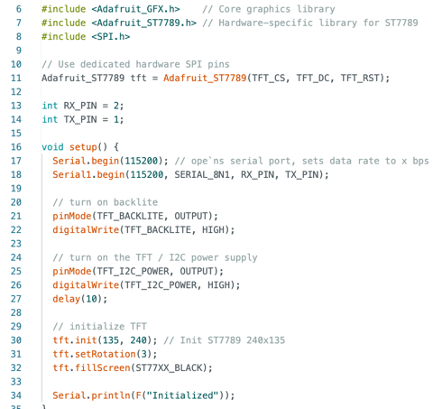**Setup:** This section of the OLED program is essentially allowing the OLED screen to read serial. You can see the same BAUD rate used for this board as the other boards. The OLED screen is different because it needs a special graphics library and some weird hardware-specific library for some reason. I included the library, so it works. After initializing the pins and covering the screen black, we can let ourselves know the system is done getting ready.

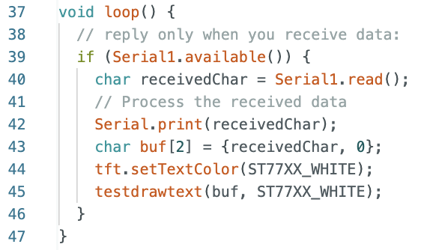**Loop:** The void loop is incredibly simple. We just look for if a serial bit has come in. For this case we don’t care if it is one character at a time. We just grab the character and then both print that character back to the PC. But also draw the character on the screen. We can use the white color to draw the letters.

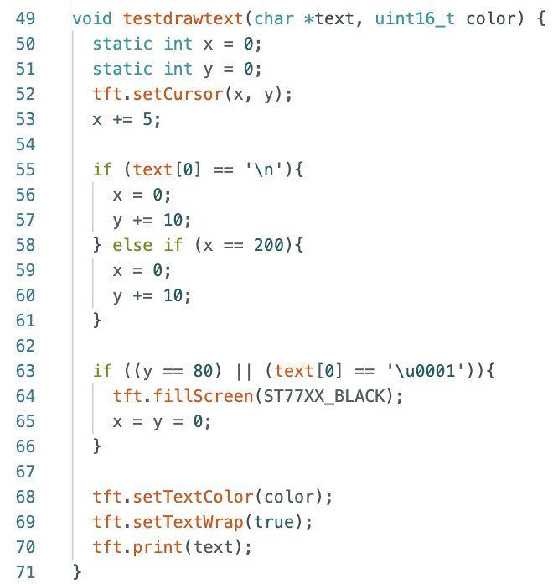

**Drawing the text:** Whenever we need to draw the text we need to use the special graphics library to do the stuff. We need to set a cursor location on the OLED screen and then from that cursor we can type text. Every time we draw a new character we increase the x position of the cursor by 5 units. Since we declared statics in there, they are on the global scope. They are remembered on the next function call. After a bit the text will run off the screen so we can reset x back to zero after reaching 200 or a newline character. Then we can shift down by one by increasing y by 10. So if we reach either y = 80 or we get that Unicode escape character, we can reset the cursor position and erase the screen by setting it to black. A couple other things are called at the bottom that are related to the graphics library. They aren’t too important.

**Programming**

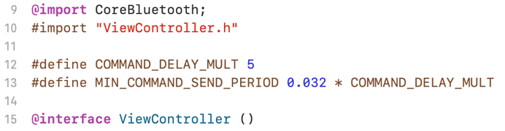**IOS Application:** The IOS application is meant to mirror the control scheme originally meant to be mounted on the vehicle itself. A car driven by a device you have to look at is not the best nor the safest way to drive. As this prototype is a concept, we can lift some of these restrictions because the small model is safe. The application’s job is to automatically send commands to the vehicle in such a way that the vehicle can interpret them and do certain tasks. The IOS application must also be compatible with the BLE server hosted on the vehicle and provide controls to both driving, steering, as well as all the light modes. The text field was an added feature to be able to debug or send certain commands. Below will be an in depth explanation about the entire XCode Objective-C program.

**Setups:** First some Core Bluetooth stuff is imported that allows Apple devices to control the Bluetooth capabilities. These include Centrals, Peripherals, Characteristics, Service, UUID, Advertisement, ATTRequests. These all come in as header files that have their own functions. Next we import the header file for the View Controller This just defines the API for the View Controller with a Central Manager Delegate and Peripheral Delegate. This also imports some UI stuff for the screen. Next are two defines for some static variables. These are the command delay rates that define how commands are slowed down. This is necessary because of how the BLE commands can be sent extremely fast, to the point where they start stacking on the BLE server buffer and cause “Lag” for the vehicle’s response. These delays limit how fast the Phone will send these commands to get rid of this problem. Next we interface the view controller in the main program.

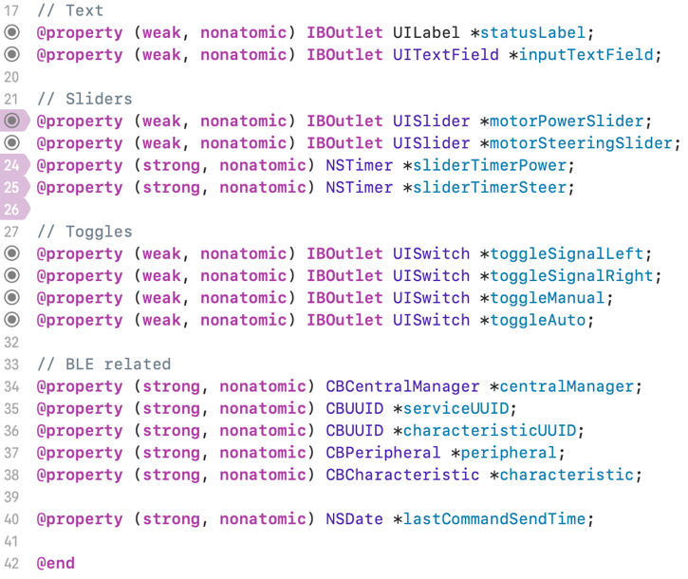

**Property setup:** Inside the interface part, just like void setup in Arduino we use @interface and @end around the properties. Some properties include some labels, a text field, some sliders, toggles, and some BLE related stuff like the Central Manager, service and characteristic UUIDs, peripheral and the BLE characteristic. If you remember the BLE characteristic from the BLE server in the ESP32-WROVER-E, this is the same one we write to and can send commands as little packets for the vehicle to receive. The last property is a last command send time which helps out with the extremely fast command send rate that BLE is capable of doing.

**Implementation:** The entire rest of this section of code is encompassed in the @implementation ViewController. Inside this section are members called instance methods which are basically a ton of – (void) or – (IBAction) [Callbacks]. Think of this section as like void main() in C++.

**Programming**

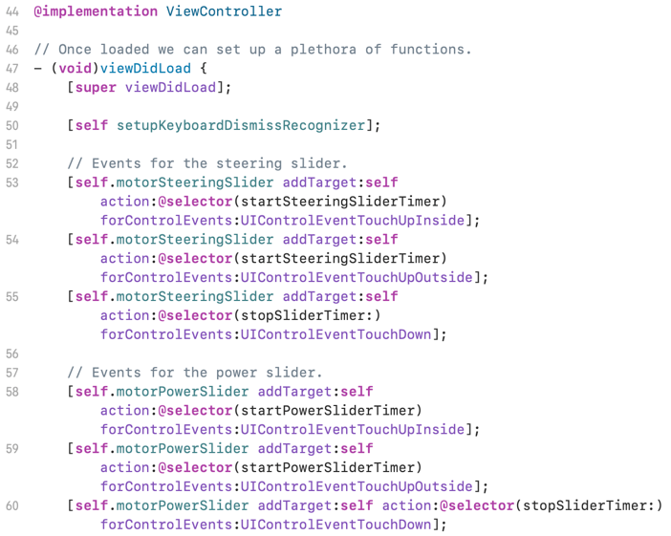**On Loading:** On this section we do a couple things as soon as the view has been loaded. We call self setupKeyboardDismissRecognizer which helps dismiss the keyboard when we tap anywhere on the screen other than the keyboard. (This will be explained later why it is useful.) For both sliders there are some callback setups. This is because when the sliders are let go, they automatically go back to zero. Timers start when we let go outside and inside the slider domain, and the timer stops when we touch down on the screen. This is done for the steering and power sliders.

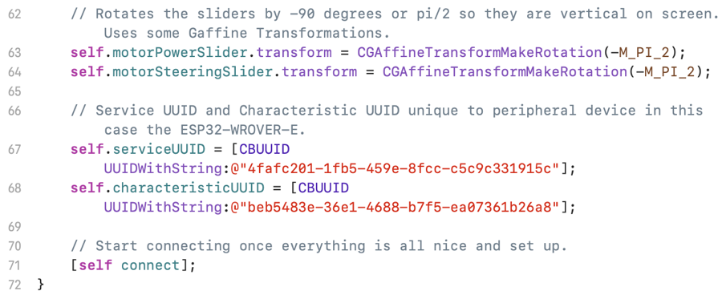**Slider fix and BLE setup:** So on apple devices, sliders are usually horizontal, by using a CGaffine Transform I can just rotate these 90 degrees. This is why the sliders on the app are vertical and horizontal in XCode. If you remember the service and characteristic UUID from the BLE peripheral, they should be exactly the same here. They are just redefined here as the same strings that were in the BLE server program. This allows our device to search for UUID rather than advertisement titles. At the bottom we can start connecting by calling the connect method.

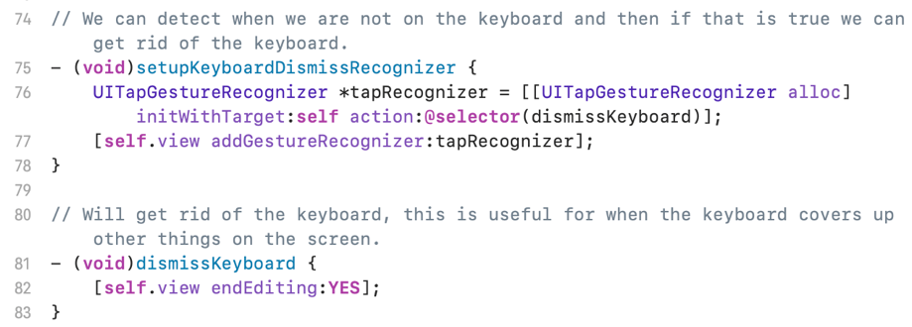**Keyboard:** When using the keyboard, it covers up the buttons on the bottom of the screen. There is a callback above that detects if you are not using the keyboard using the UI stuff imported earlier. We can end editing the keyboard by calling that dismiss keyboard method.

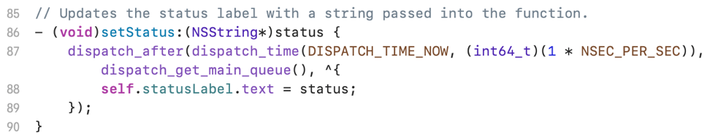**Status Label:** At the top of the screen there is a status label which should be showing the current state of the BLE connection. This was generalized to accept a NSString called status we can use to update that label during different stages of the BLE connection process as well as command sending.

**Programming**

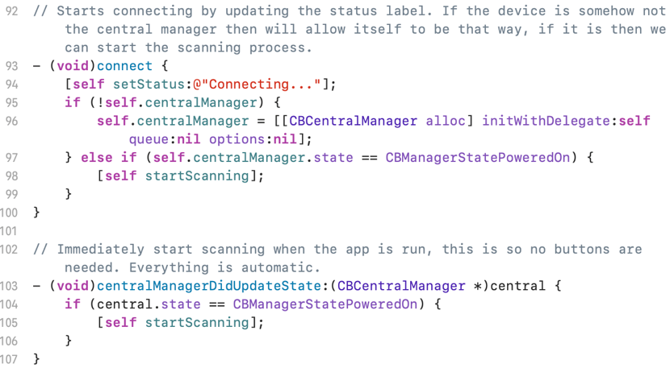

**Connecting and powering on:** So when we are running the app the phone doesn’t know yet that it should be the central manager. On connect we should check if we are the central manager. If we aren’t we can initialize the phone, (anyone’s phone) to be the BLE central. Else we can just do the scanning process. Also, if we just turn on and we are already the central, we can just immediately start scanning. These processes are automatic.

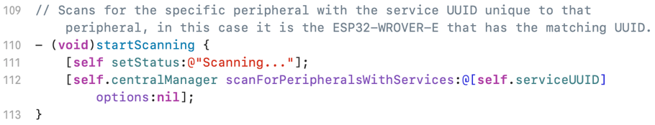**Scanning:** The status label in this section is set to scanning like the last section where it was set to connecting, in scanning we are looking for that serviceUUID.

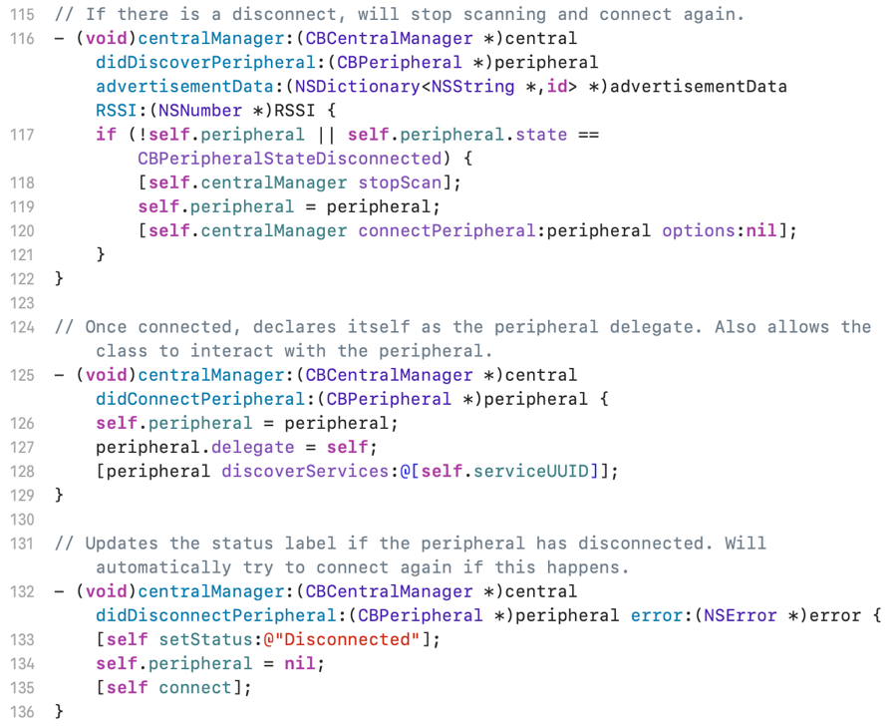**Peripheral:** There are three centralManager methods that do different things based on what interactions are done with the peripheral device. If we discover the peripheral, get some advertisement data, or an RSSI, we can see if the peripheral is actually a peripheral or if the peripheral has been disconnected. If that happens we can stop scanning, reconfigure the peripheral and try reconnecting again. The second one goes if we just connected to the peripheral. We can configure the peripheral in this block and then discovers the serviceUUID. Idk why we need to discover it but it is necessary to interact with the device. The last block specifically looks for disconnects and can set the status to disconnect. If disconnecting happens just like if the peripheral was discovered, advertisement data received, or the RSSI number method, we can restart the connection process here too. These are several somewhat annoying but necessary pieces of code that make sure nothing goes wrong when connecting or disconnecting. Possibly in the future this section can be cleaned up a bit or improved. For instance for better debugging the status label at the top of the screen can be set to a descriptor in the top two methods to show where the program has reached a stop.

**Programming**

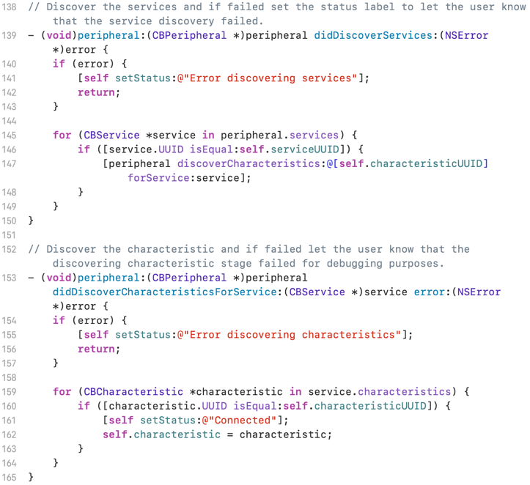

**Discovering the service and characteristic:** So we still need to discover the service and the characteristic which are different from the UUIDs. In these peripheral methods we can see if there was an error discovering one of these and if something happens set that status up at the top to the error that happened. This can help catch typos when defining the UUID or some other hidden bug. For loops make sure to go through the characteristics or services and try to reconfigure/discover them all. Keep in mind this stuff happens when the peripheral method is called too.

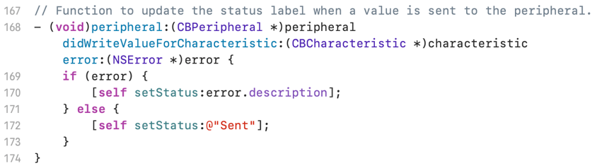**Characteristic on write:** If the user can somehow type something that causes an error, the error will be set to the status label. Normally this isn’t the intent so when a command is sent, aka the characteristic is changed, the label changes to “sent” as a way to let the user know.

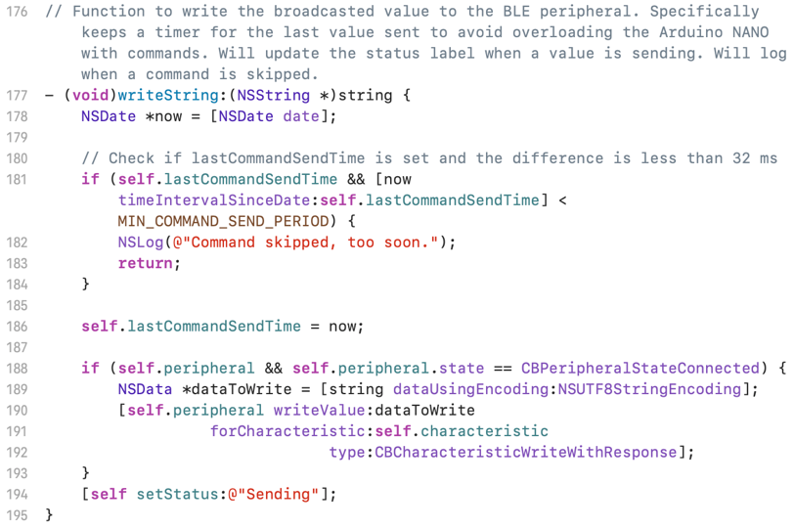**Command Delay:** The vehicle is only able to do commands at a certain frequency. NSDate is a timer that runs in the background. It isn’t hindered by any slowdowns in the code. If our last command time is set and the interval of time since the last command was sent vs the current timer, we need to skip that command. That first if is essentially a guard statement to make sure we don’t send commands to fast. If we don’t hit that if we can set the last command time to the timer and then write to that characteristic with that gigantic self.peripheral writeValue statement. If we are actually connected to a peripheral and the peripheral is set, then we can write the string passed into the write string method to the characteristic. This is then sent as a packet to the BLE server to intercept, open up, and interpret. After everything is done, we set the status to sending to let the user know that we are in the process of sending. The method above didWriteValueforCharacteristic checks if it is good.

**Programming**

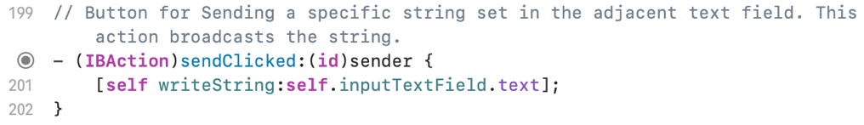

**Send Button Event:** When we tap the send button, we want to just call that writeString method with whatever is in the text field. That process is called here in the event. The circle on the left links this to that button [Send] on the screen in the app.

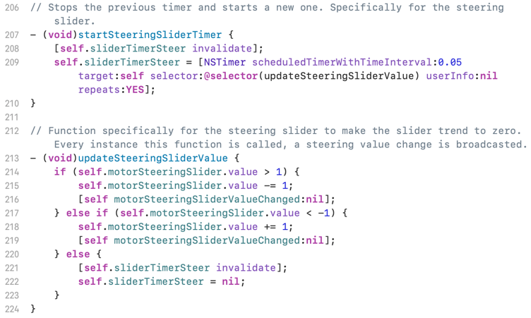

**Slider Timers:** Both the power and steering sliders have the same timer code. So in this little section, only the steering slider is shown but both do an equivalent effect. When we start a timer we cancel the old one, that is done in the invalidate call. Then we can set a timer, specifically for the steering slider in this case, with an interval of 0.05 and set it to repeat. It also happens to call the updateSteeringSliderValue method. When that is called it checks the slider value and changes the slider value automatically depending on its position. Every time a slider value is changed we need to send that as a command to the vehicle so we get gradual change in speed and steering. If we happen to be around zero, then we can stop the timer.

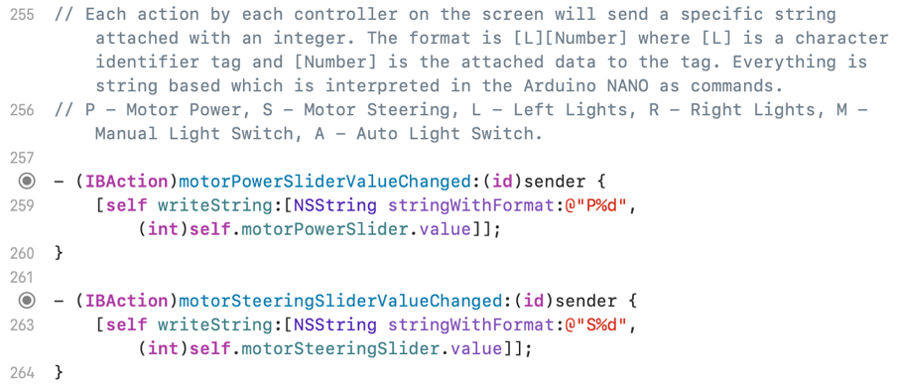

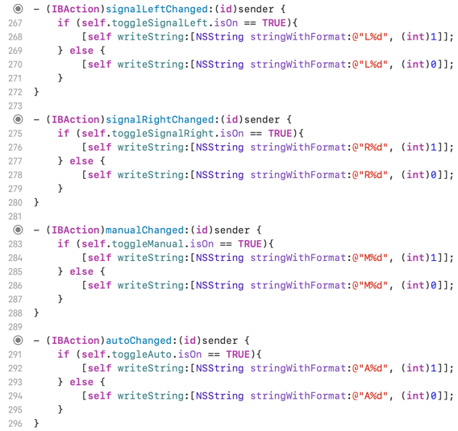**Slider values changed:** Whenever the sliders are changed we need to send that value. So each time these events happen we write the string with the format “T%d” where T is the letter for the tag, P and S in this case for power and steering, and then after that is the value for the slider. This sending format is compatible with the Arduino Reactions code to modify the motor movements. The exact same is done for the lights as well. You can see to the right that the lights are done in the same manner just with different tags and different values being written to the integer slot. A string parser in the BLE server code will turn the string integers into numbers to activate the various light pins on the project. These 4 actions are tied to 4 different sliding toggles at the bottom of the application. These would be often covered up by the keyboard which is why the keyboard dismissing code was necessary.

**Components**

**Components for Each Module:** The vehicle has three circuit modules, two motor modules, and one chain of microcontrollers. A list of each component used will be displayed here:

* **Turn signal Module:**
  + 1x NE555 Timer IC Chip
  + 2x PNP (BJT) Transistor [Part Number Needed]
  + 4x 330Ω Resistors
  + 2x 1kΩ Resistors
  + 1x 4.10kΩ Resistor
  + 4x Yellow Colored LED
  + 1x DigiKey PTV09A-403F-A104 100 kΩ Potentiometer
  + 10 μF Polarized Capacitor
* **Automatic lights Module:**
  + 2x NPN (BJT) Transistor KSP2222ABU
  + 1x PNP (BJT) Transistor [Part Number Needed]
  + 1x 3.30 kΩ Resistor
  + 3x 1 kΩ Resistors
  + 2x 270Ω Resistors
  + 1x 50kΩ Resistor
  + 1x Photoresistor
  + 2x Red Colored LED
  + 2x White Colored LED
* **H-bridge Module:**
  + L293D H-Bridge Chip
  + 74HC00 NAND Gate
  + Decoupling Capacitors [Part Number Needed]
  + Decoupling bleed resistors [Resistance Needed]
* **Driving Motor Module:**
  + LEGO Functions Power Functions XL-Motor 8882
* **Steering Motor Module:**
  + SG90 9G Servo
* **Microcontrollers:**
  + Arduino NANO
  + Adafruit ESP32-S2 TFT Feather OLED screen
  + ESP32-WROVER-E Devkit

**References**

https://en.wikipedia.org/wiki/Automotive_lighting#:~:text=Turn%20signals%20are%20required%20to,(1–2%20Hz).

<https://www.handsontec.com/dataspecs/HC-SR04-Ultrasonic.pdf>

<https://www.ti.com/lit/ds/symlink/drv8841.pdf?ts=1701632593952&ref_url=https%253A%252F%252Fwww.google.com%252F>

<https://docs.arduino.cc/learn/microcontrollers/analog-output>